- Reading command help in DOS and UNIX
In DOS:
E.g. dir/?
In unix:
Man commandname

- Basic and Important DOS (Windows Command Prompt) Commands:

1. dir - List contents of a directory.
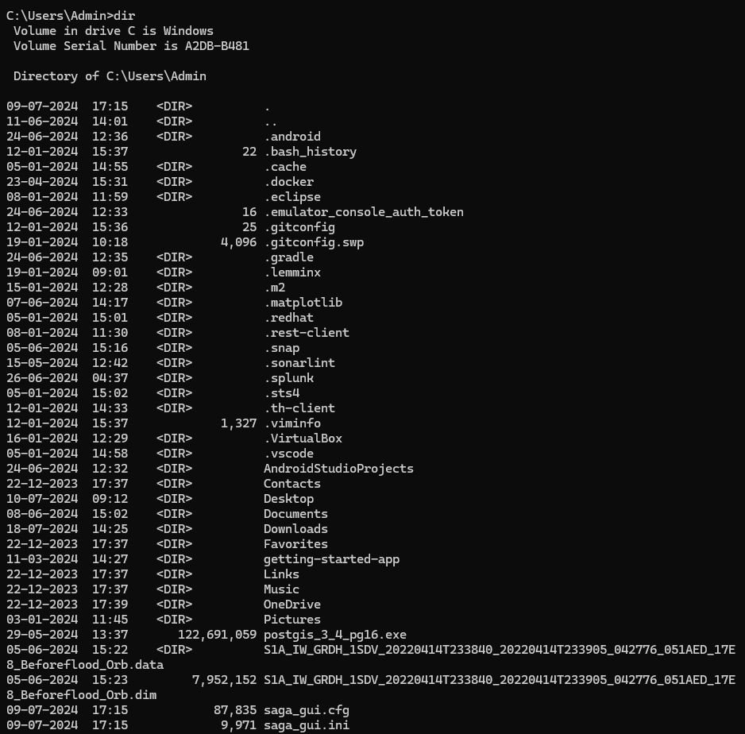
2. cd - Change directory.
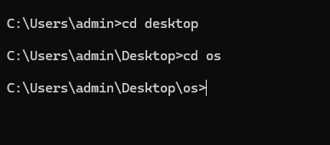
3. copy - Copy files.
4. move - Move files.
5. del - Delete files.
6. mkdir - Create a new directory.
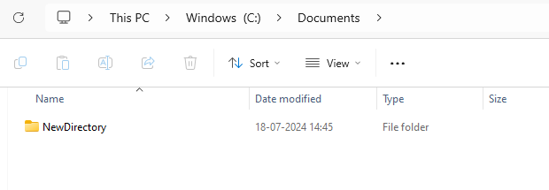
7. rmdir - Remove a directory.
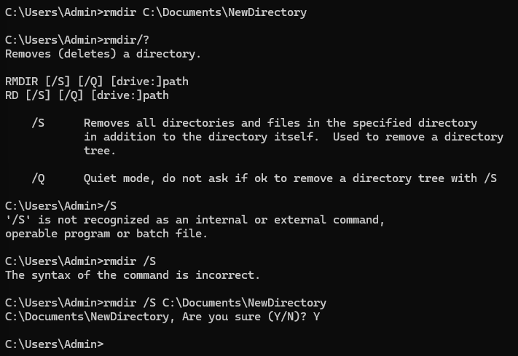
8. type - Display the contents of a file.
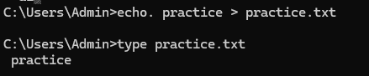
9. ren - Rename files.
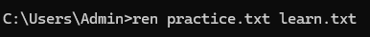
10. cls - Clear the screen.
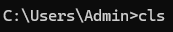
11. echo - Display messages or turn command echoing on/off.
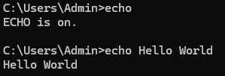
12. exit - Exit the Command Prompt.
13. attrib - Display or change file attributes.
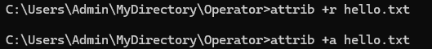
14. tasklist - Display a list of currently running processes.
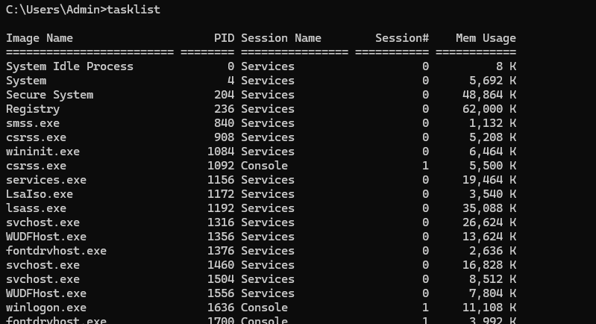
15. ping - Test connectivity to another networked device using ICMP echo.
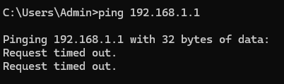
16. Create a batch file and execute
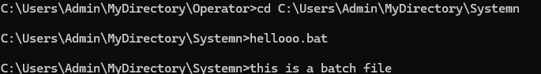

B. Basic and Important Unix (Linux/macOS) Commands:

1. ls - List directory contents.
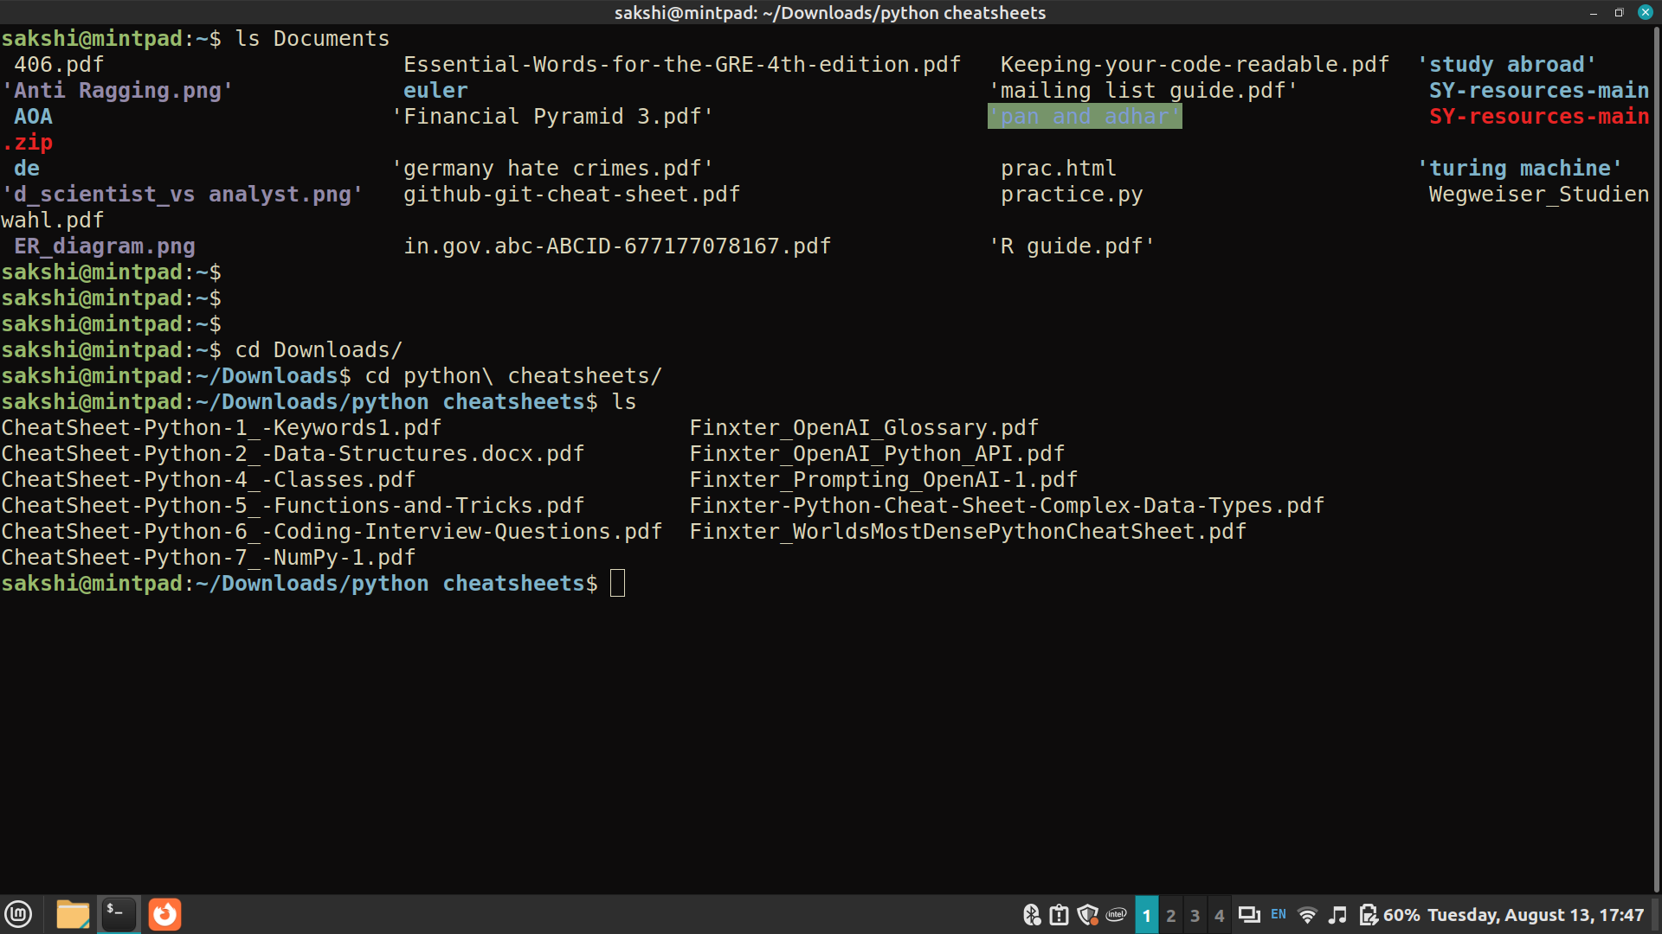
2. cd - Change directory.


3. cp - Copy files and directories.
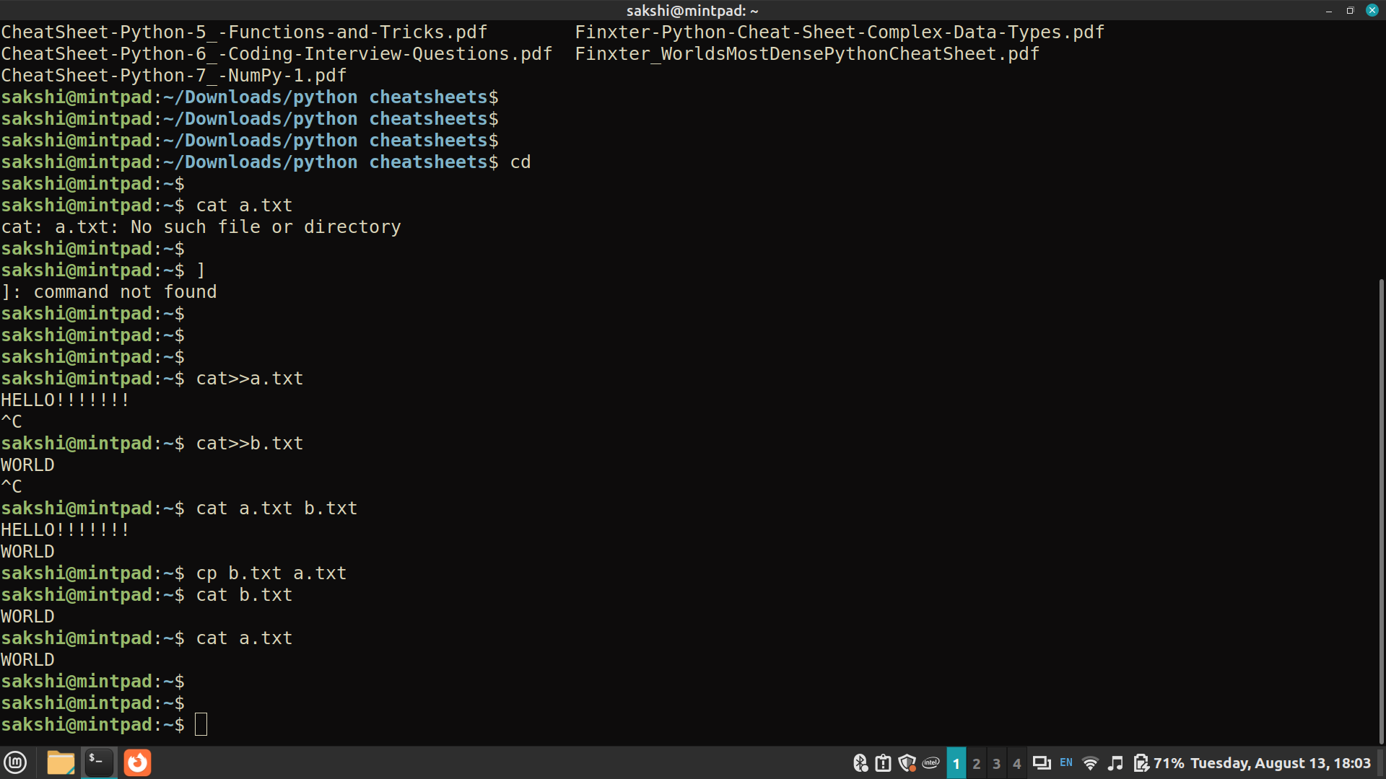
4. mv - Move/rename files and directories.
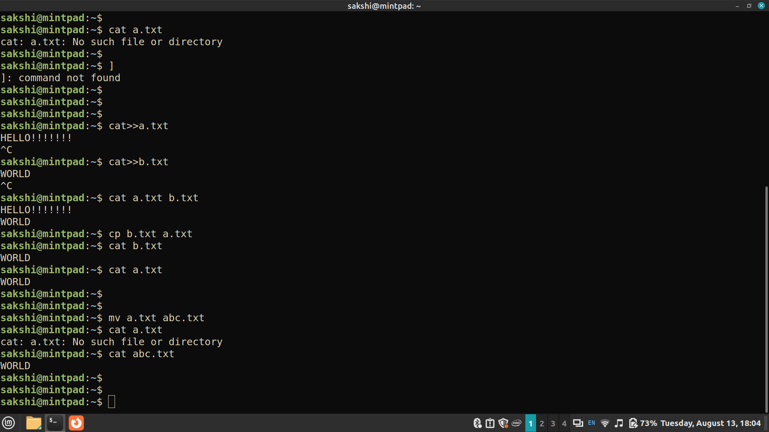
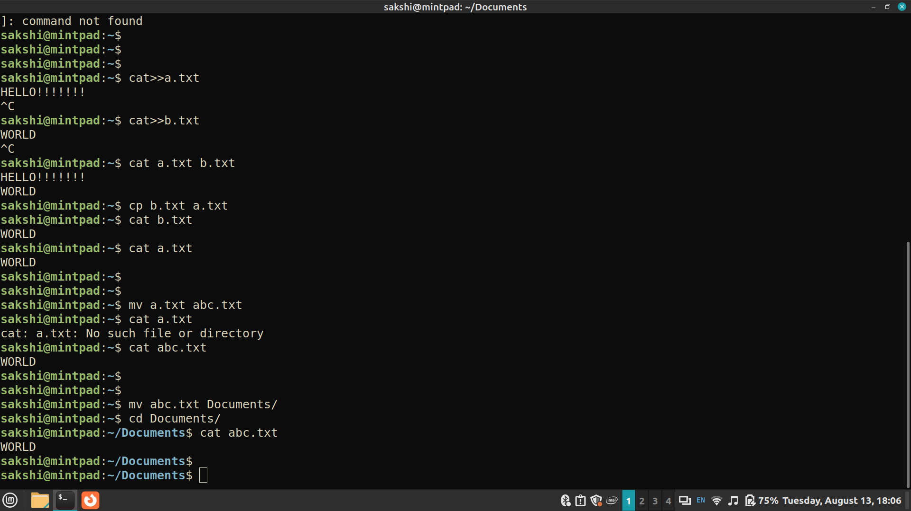
5. rm - Remove files and directories.
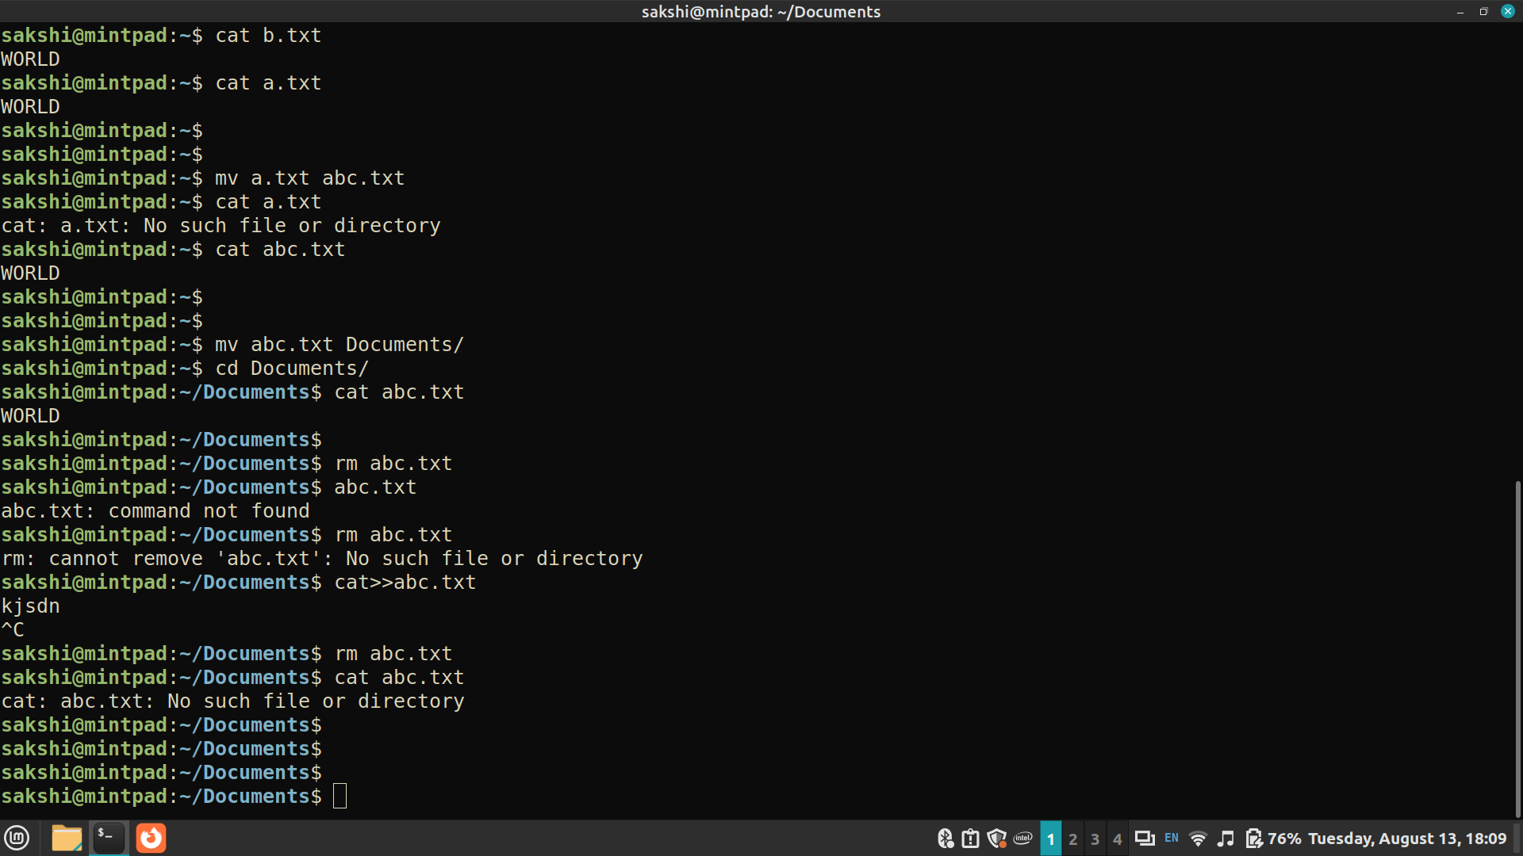
6. mkdir - Create directories.
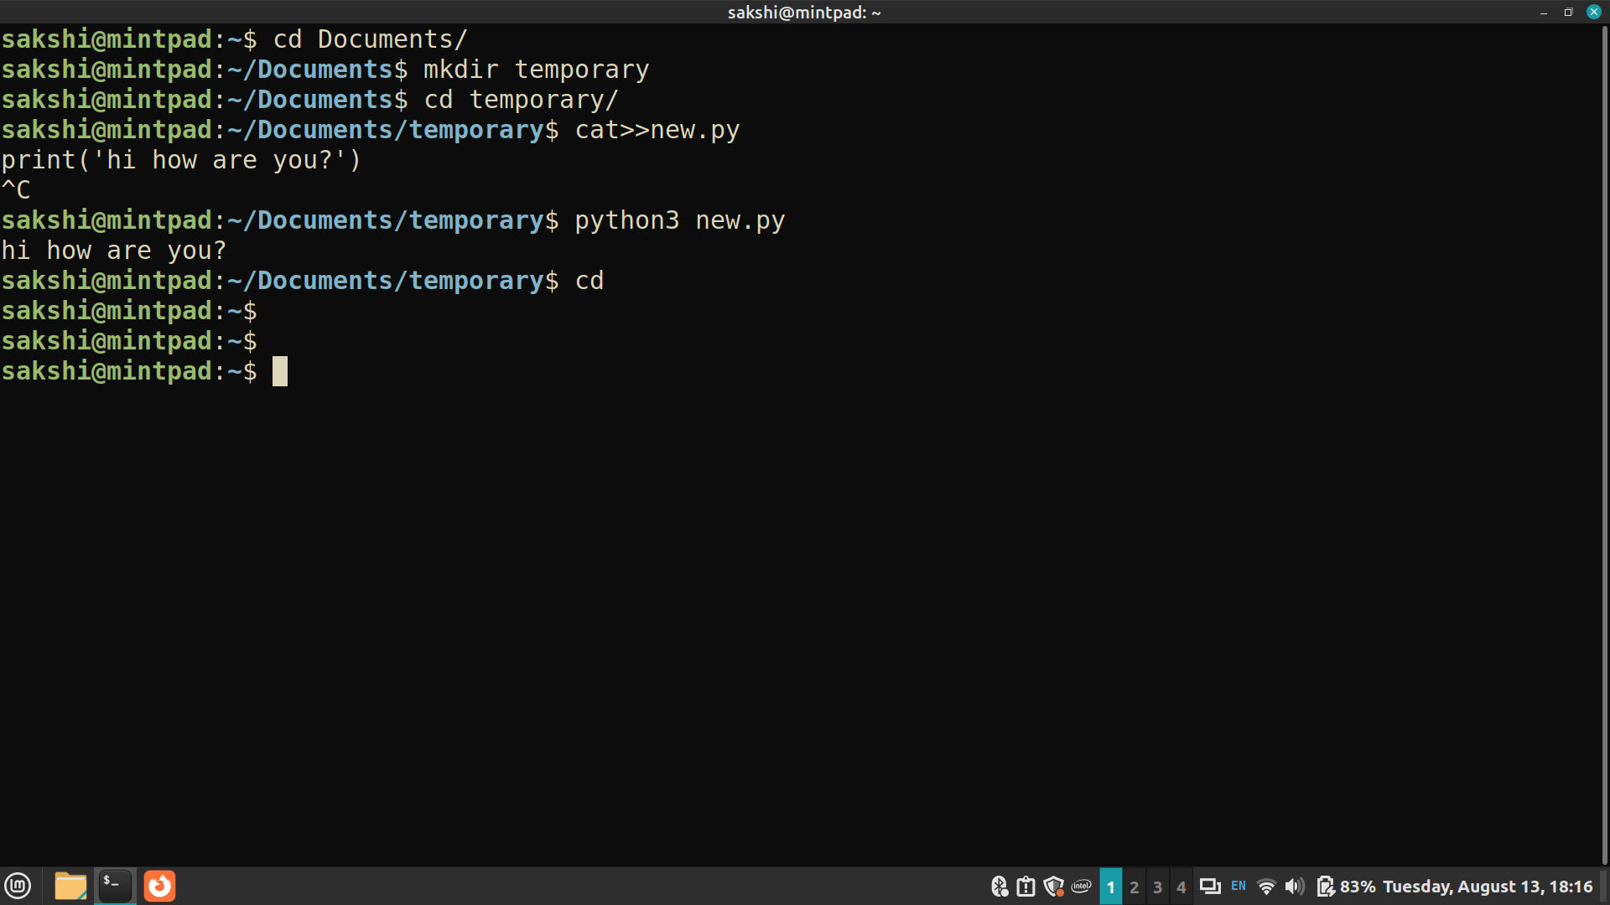
7. rmdir - Remove empty directories.
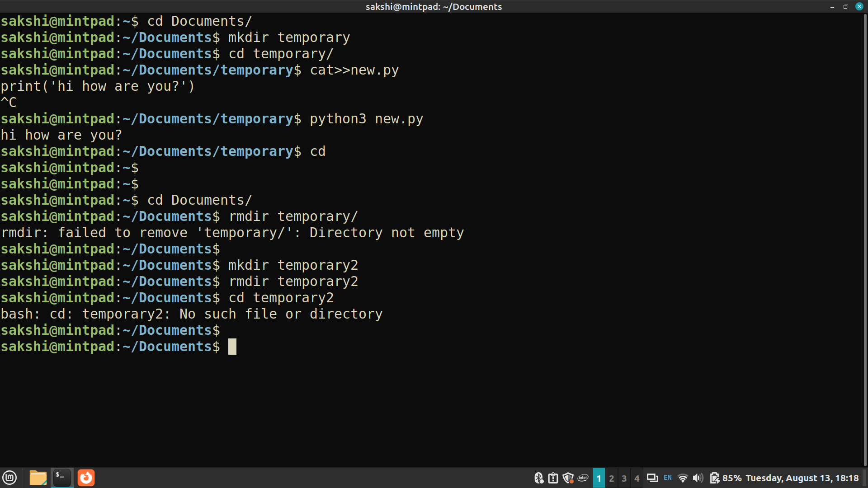
8. cat - Concatenate and display files.
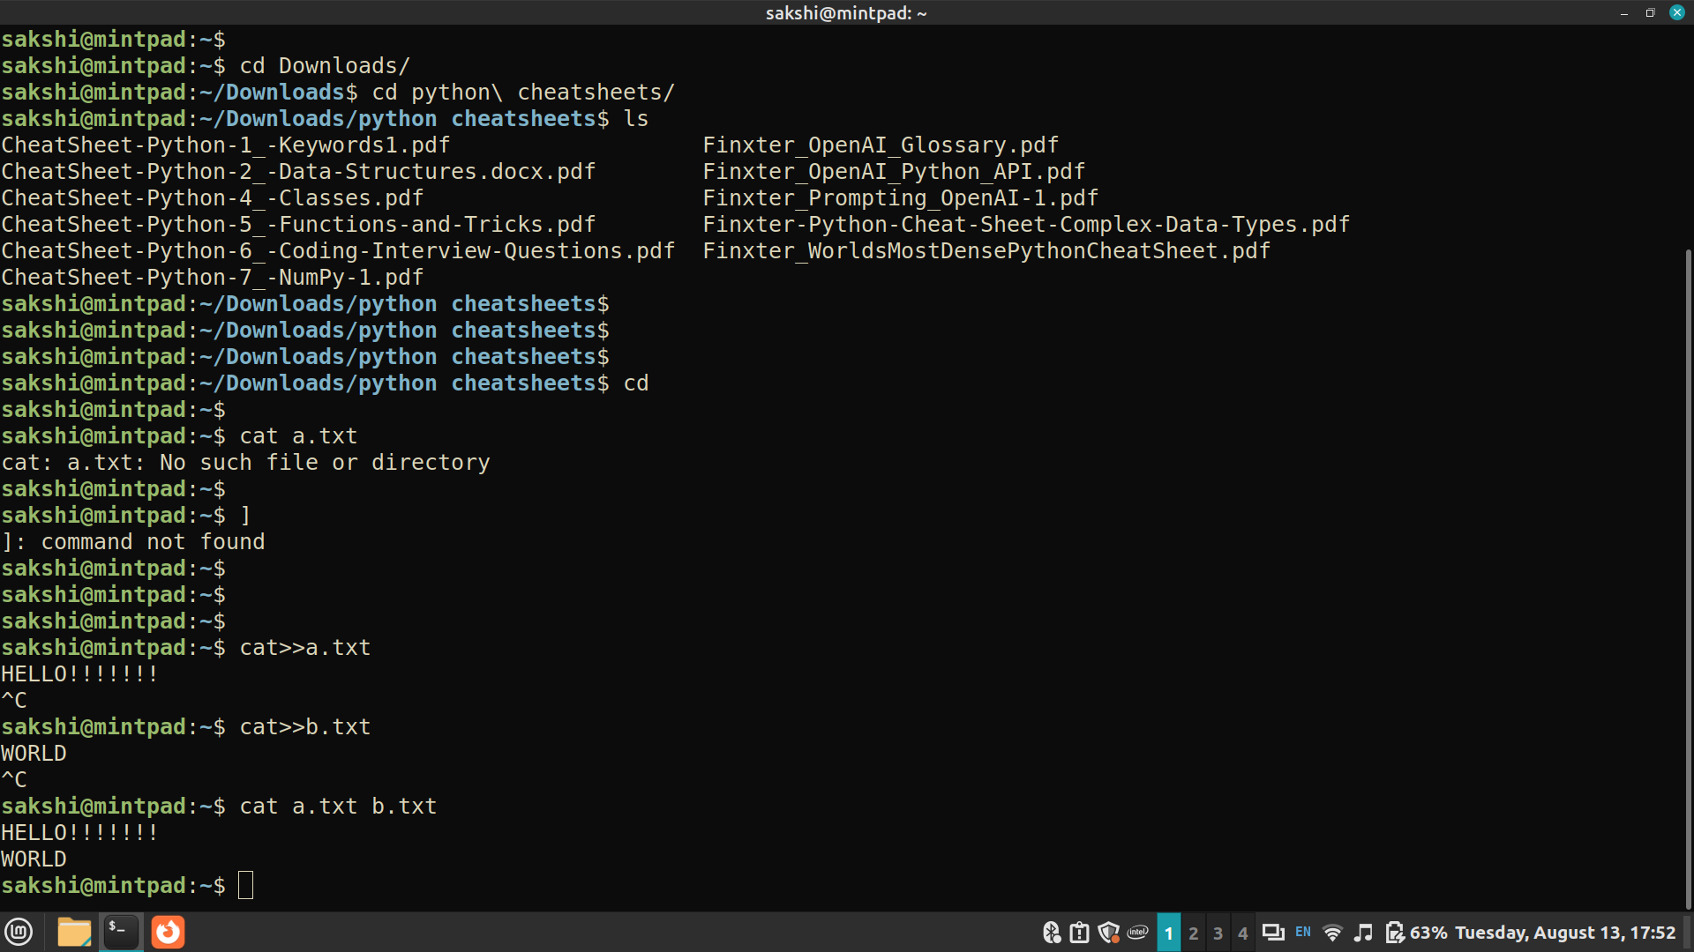
9. more or less - View file contents one screen at a time.
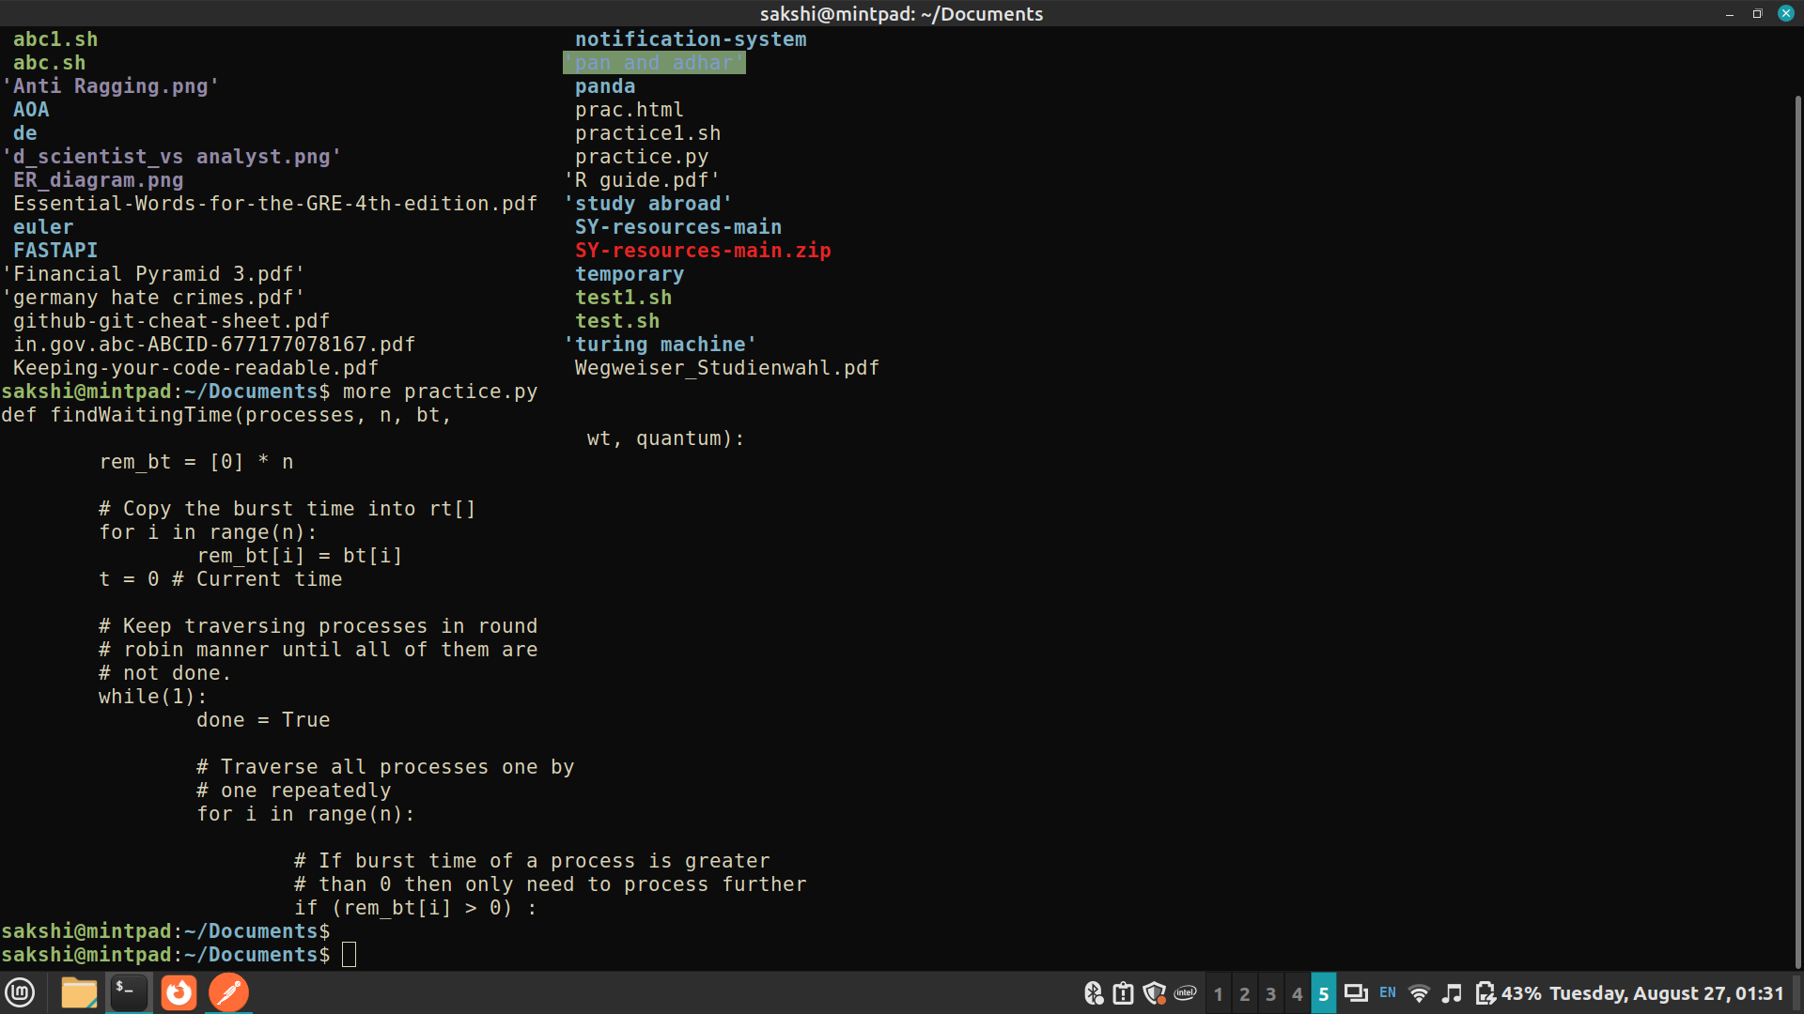
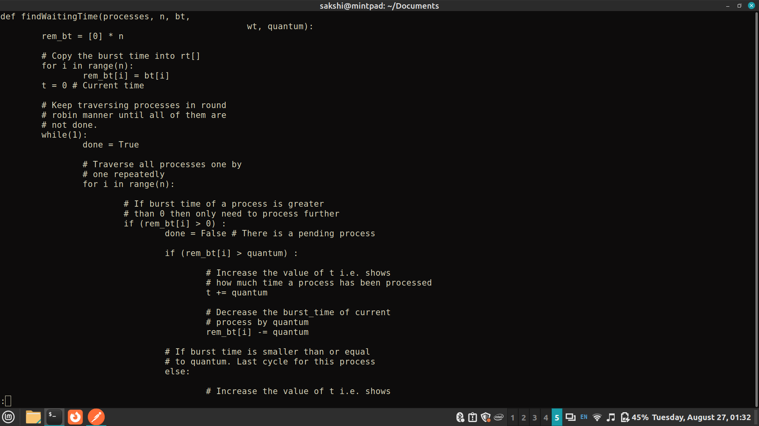
10. touch - Create an empty file or update file timestamps.
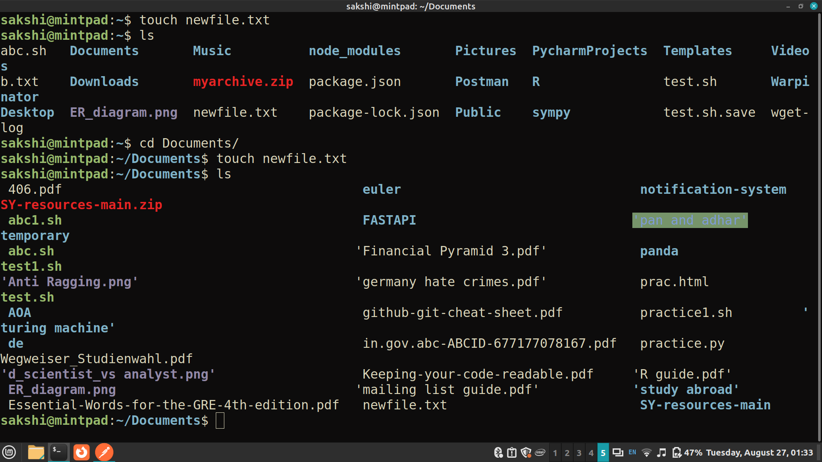
11. nano or vi (Linux) / TextEdit (macOS) - Text editors for creating and editing files.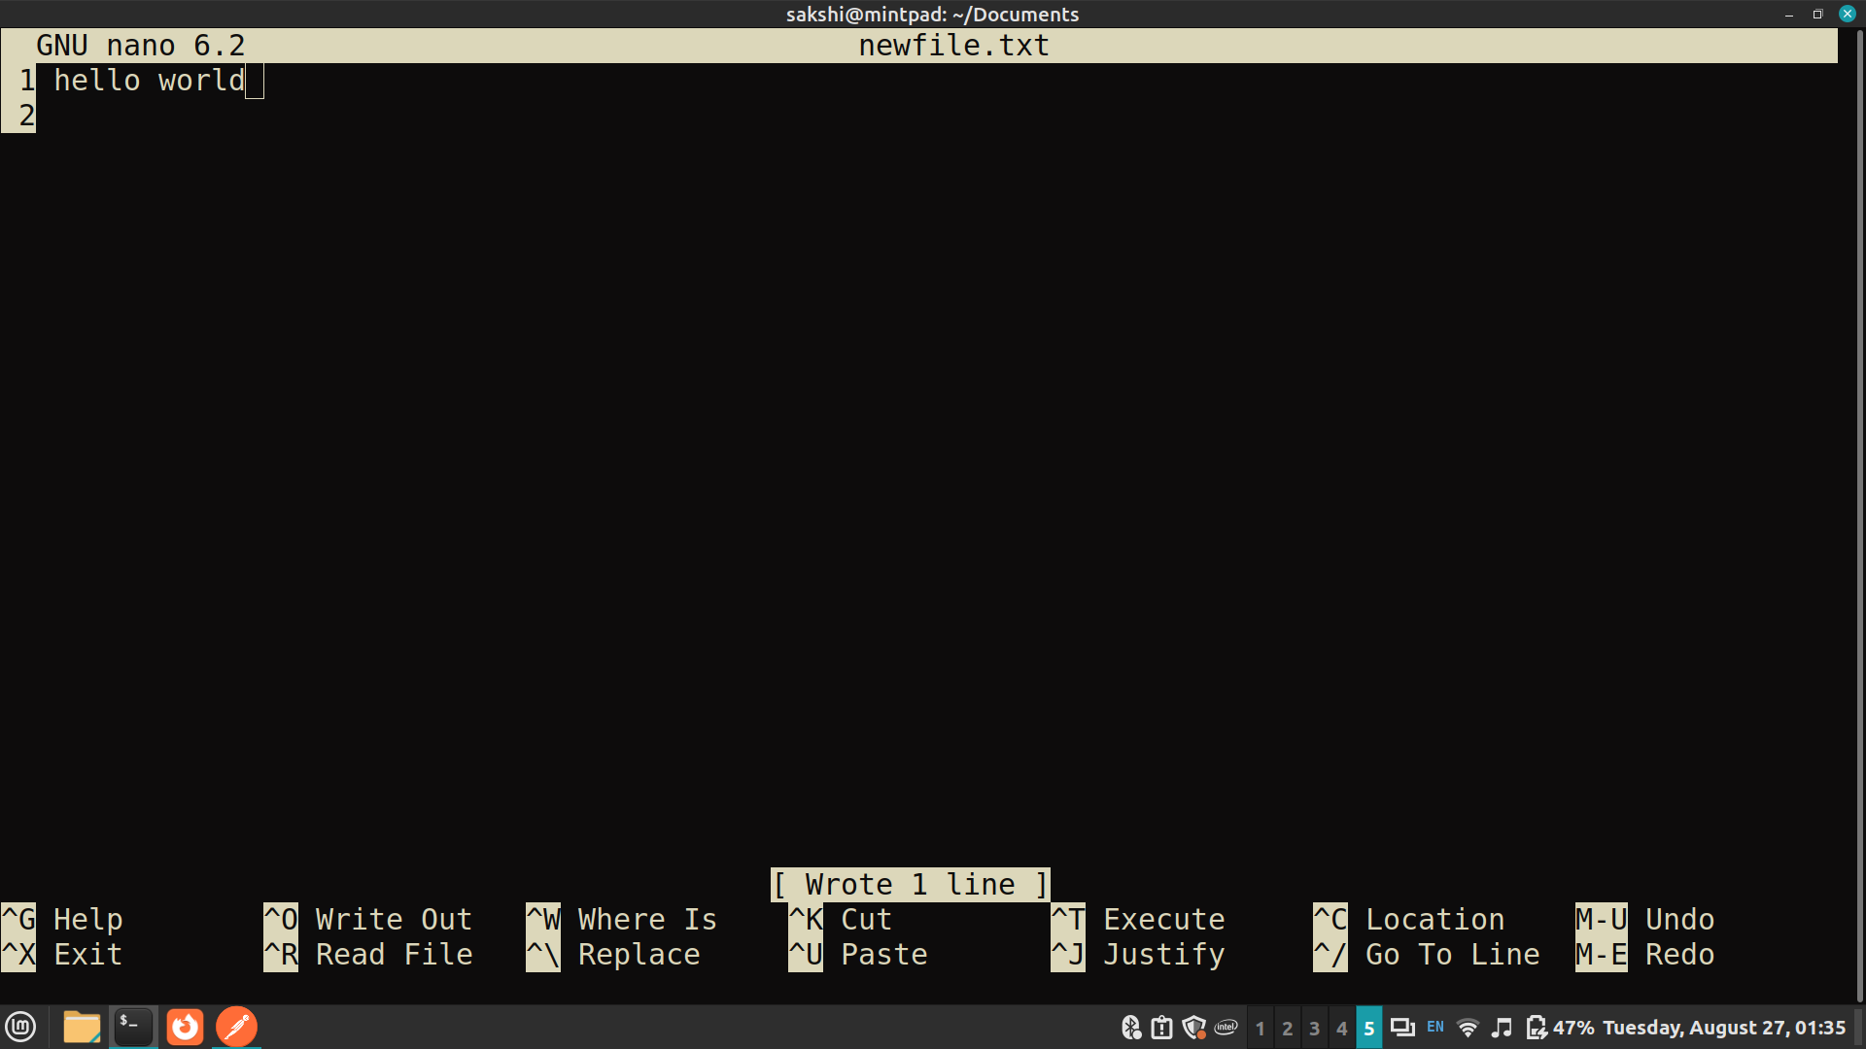
12. pwd - Print working directory.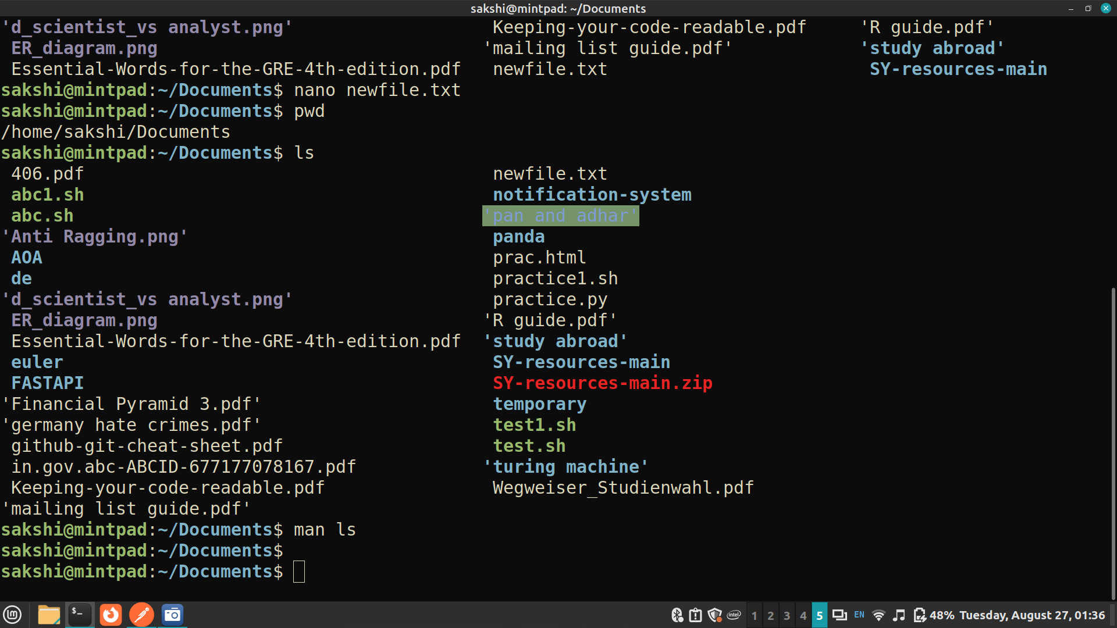
13. man - Display manual pages for commands.
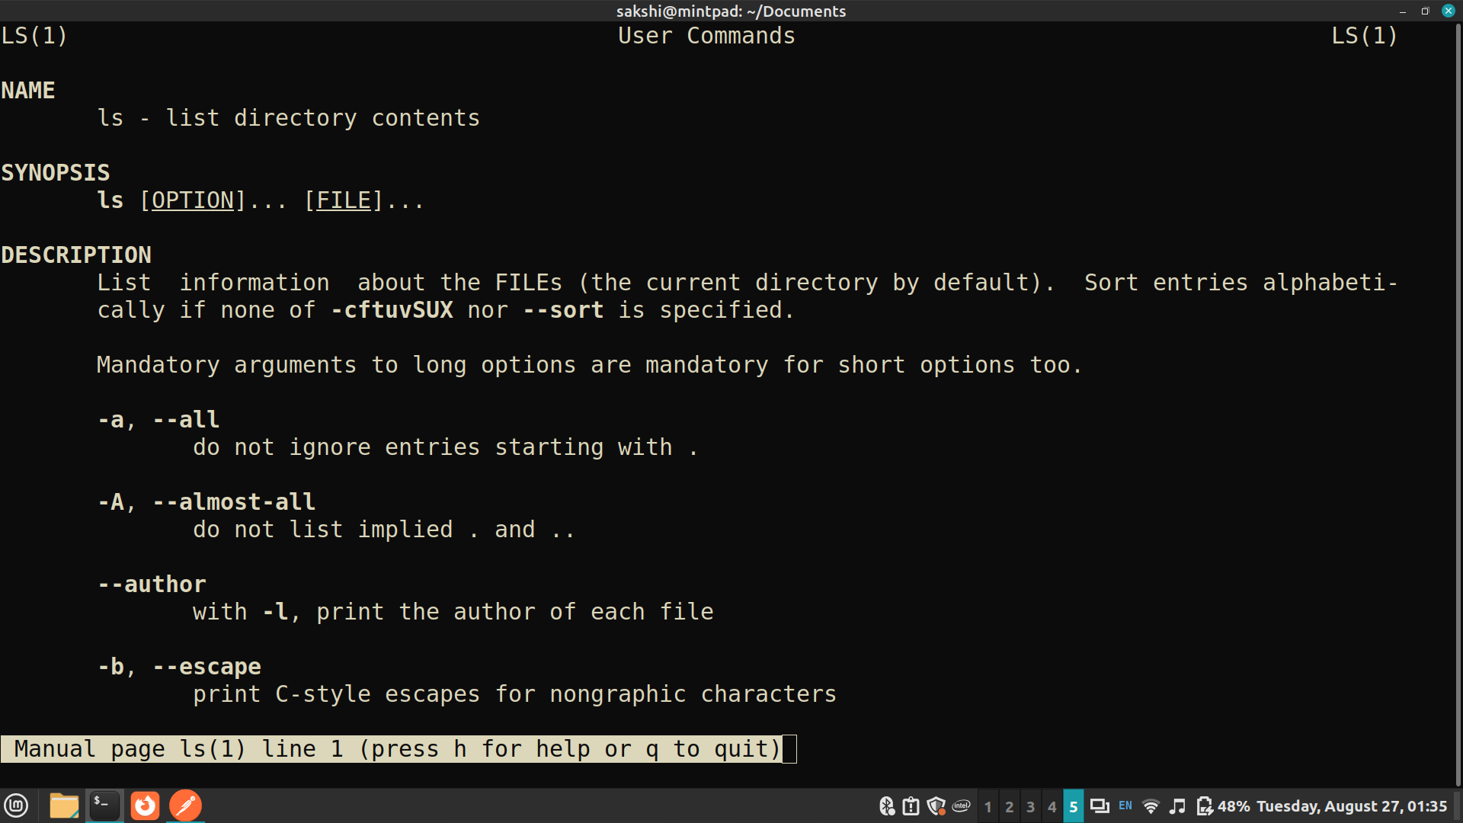
14. grep - Search for patterns in files.
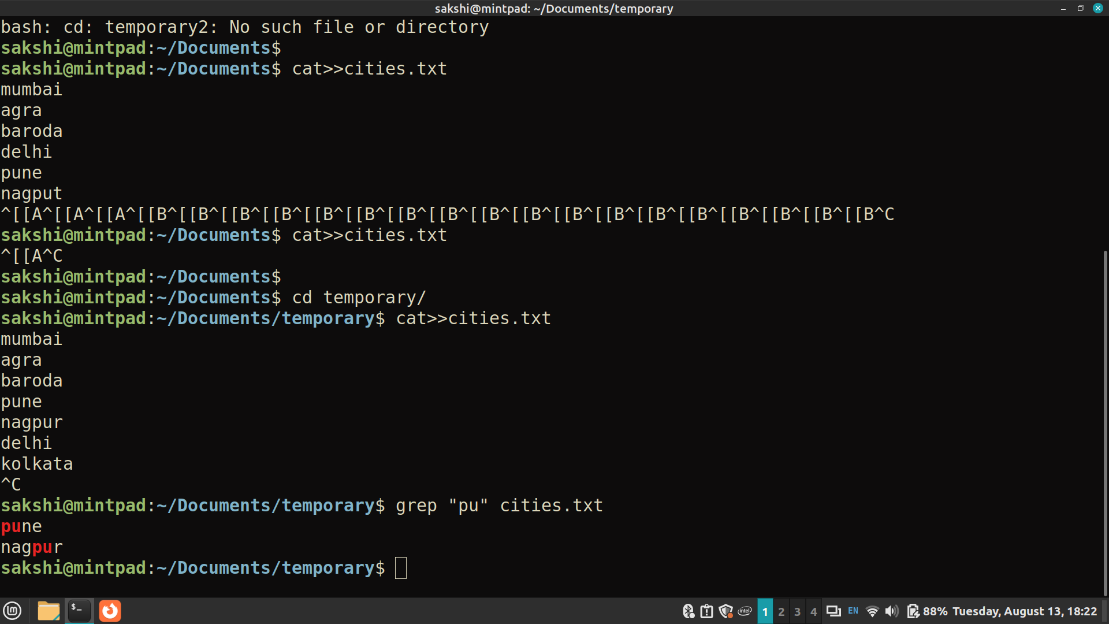
15. chmod - Change file permissions.
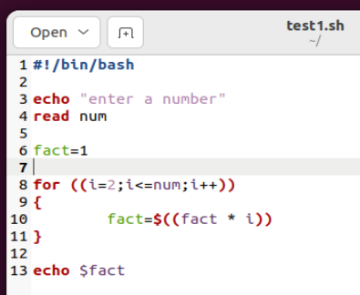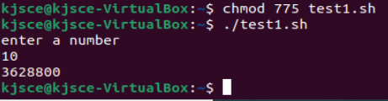
16. ps - process status
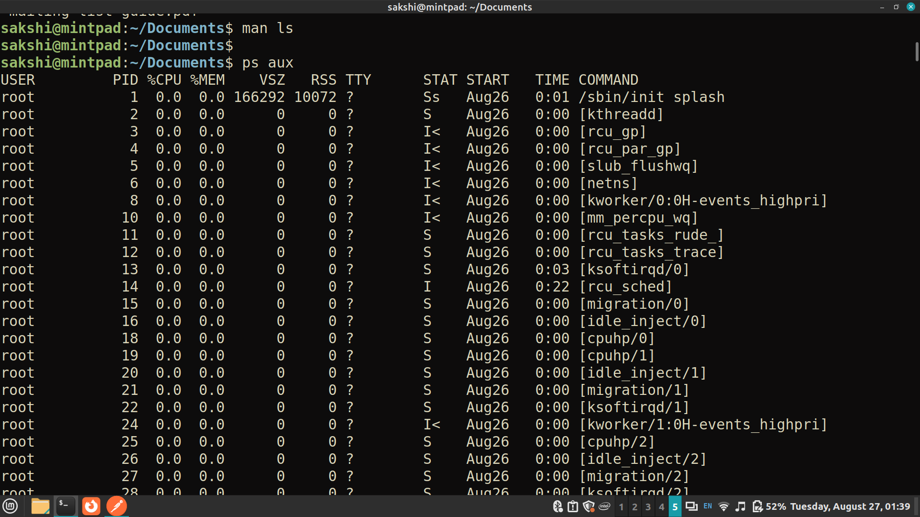
17. kill - terminate a process
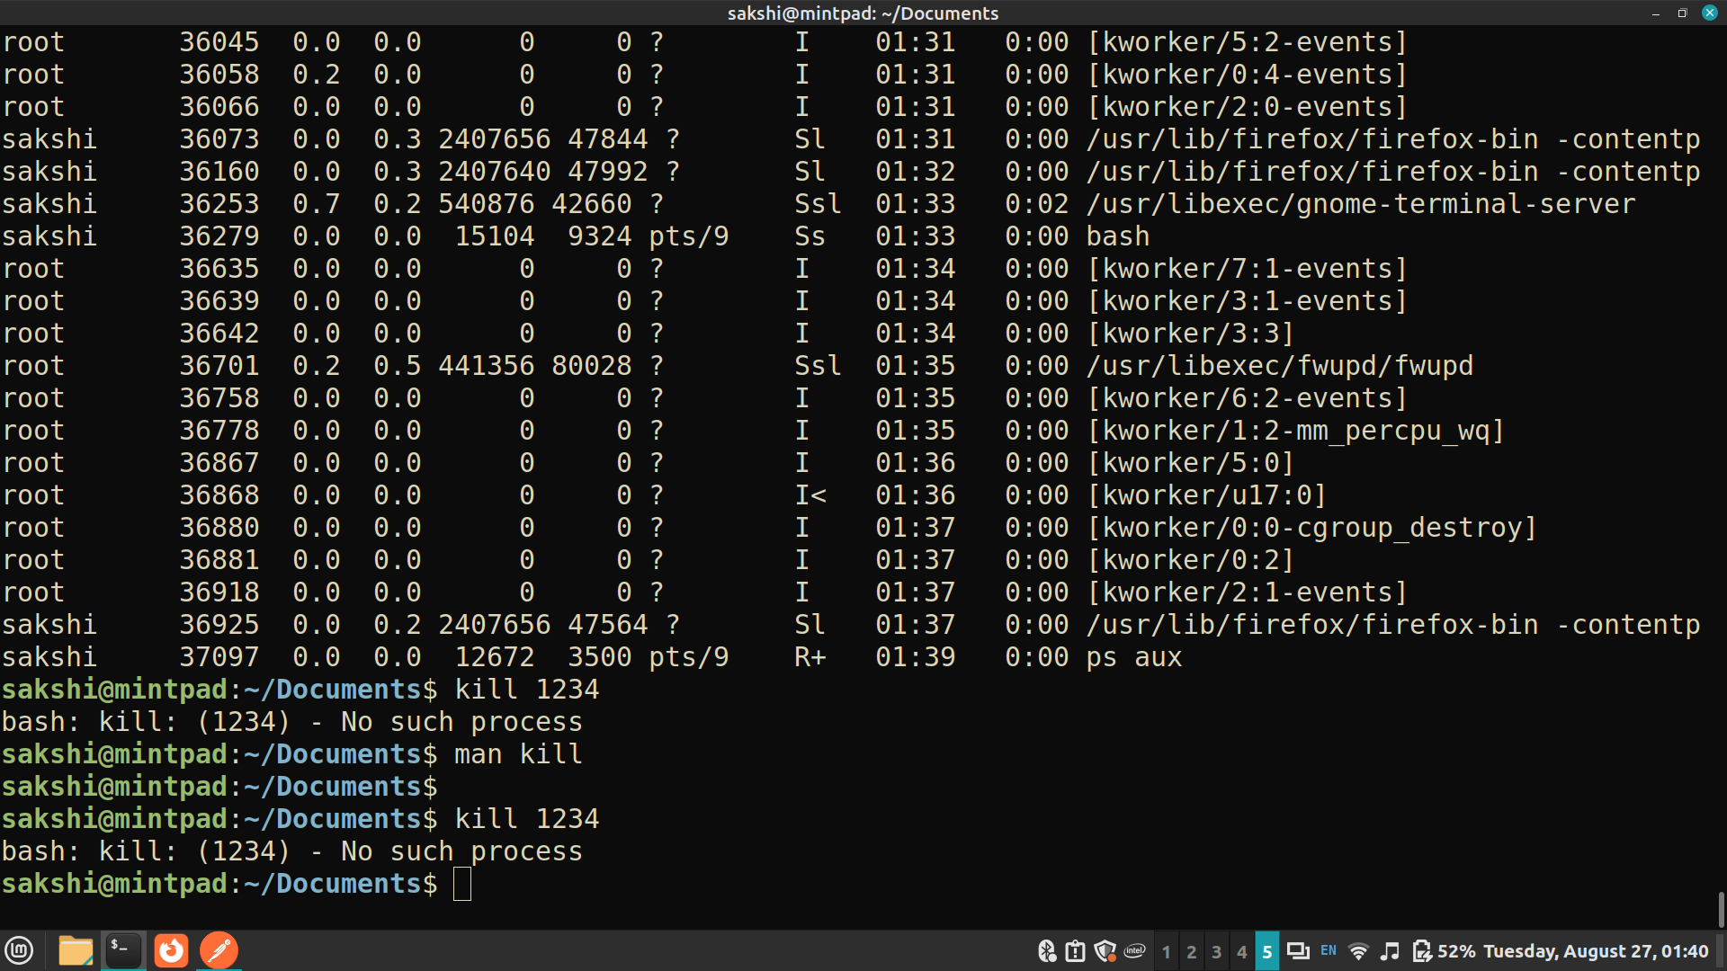
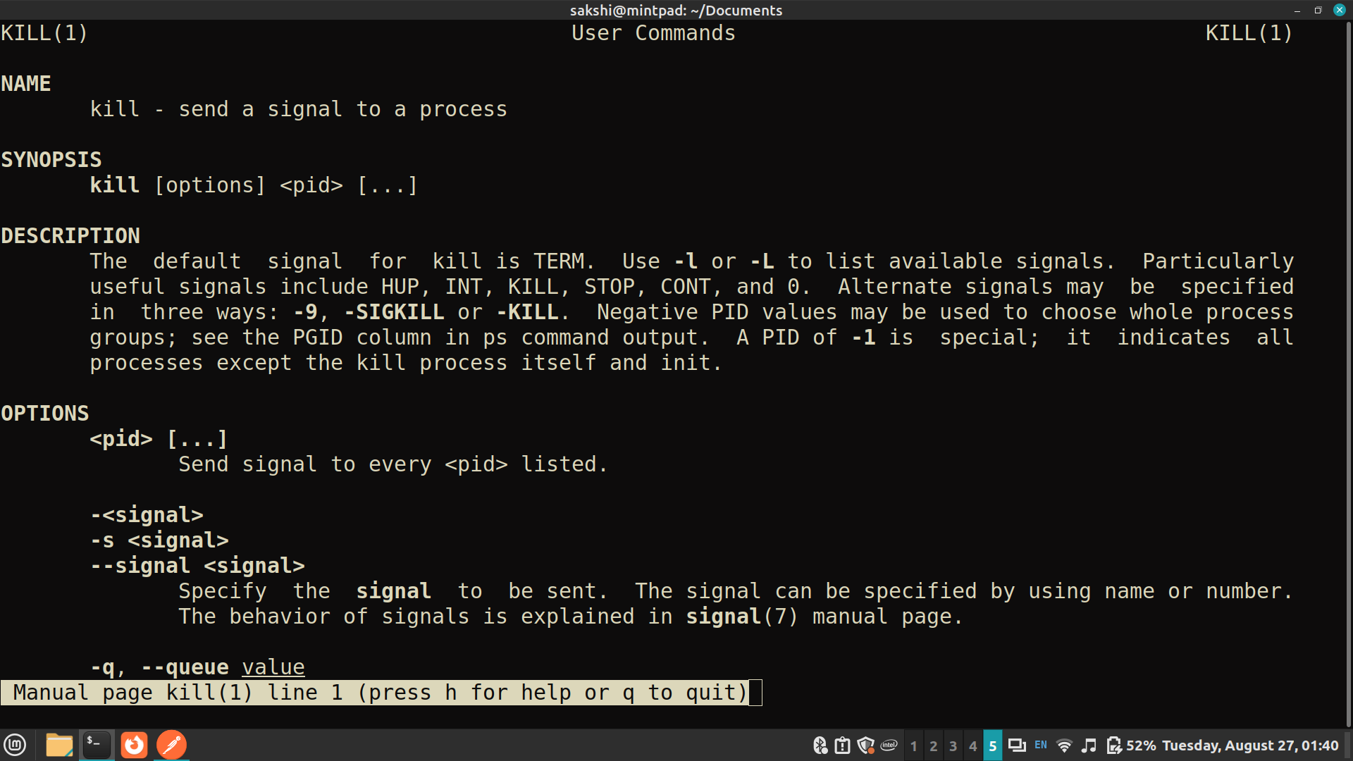
18. runlevel - get number of system runlevels
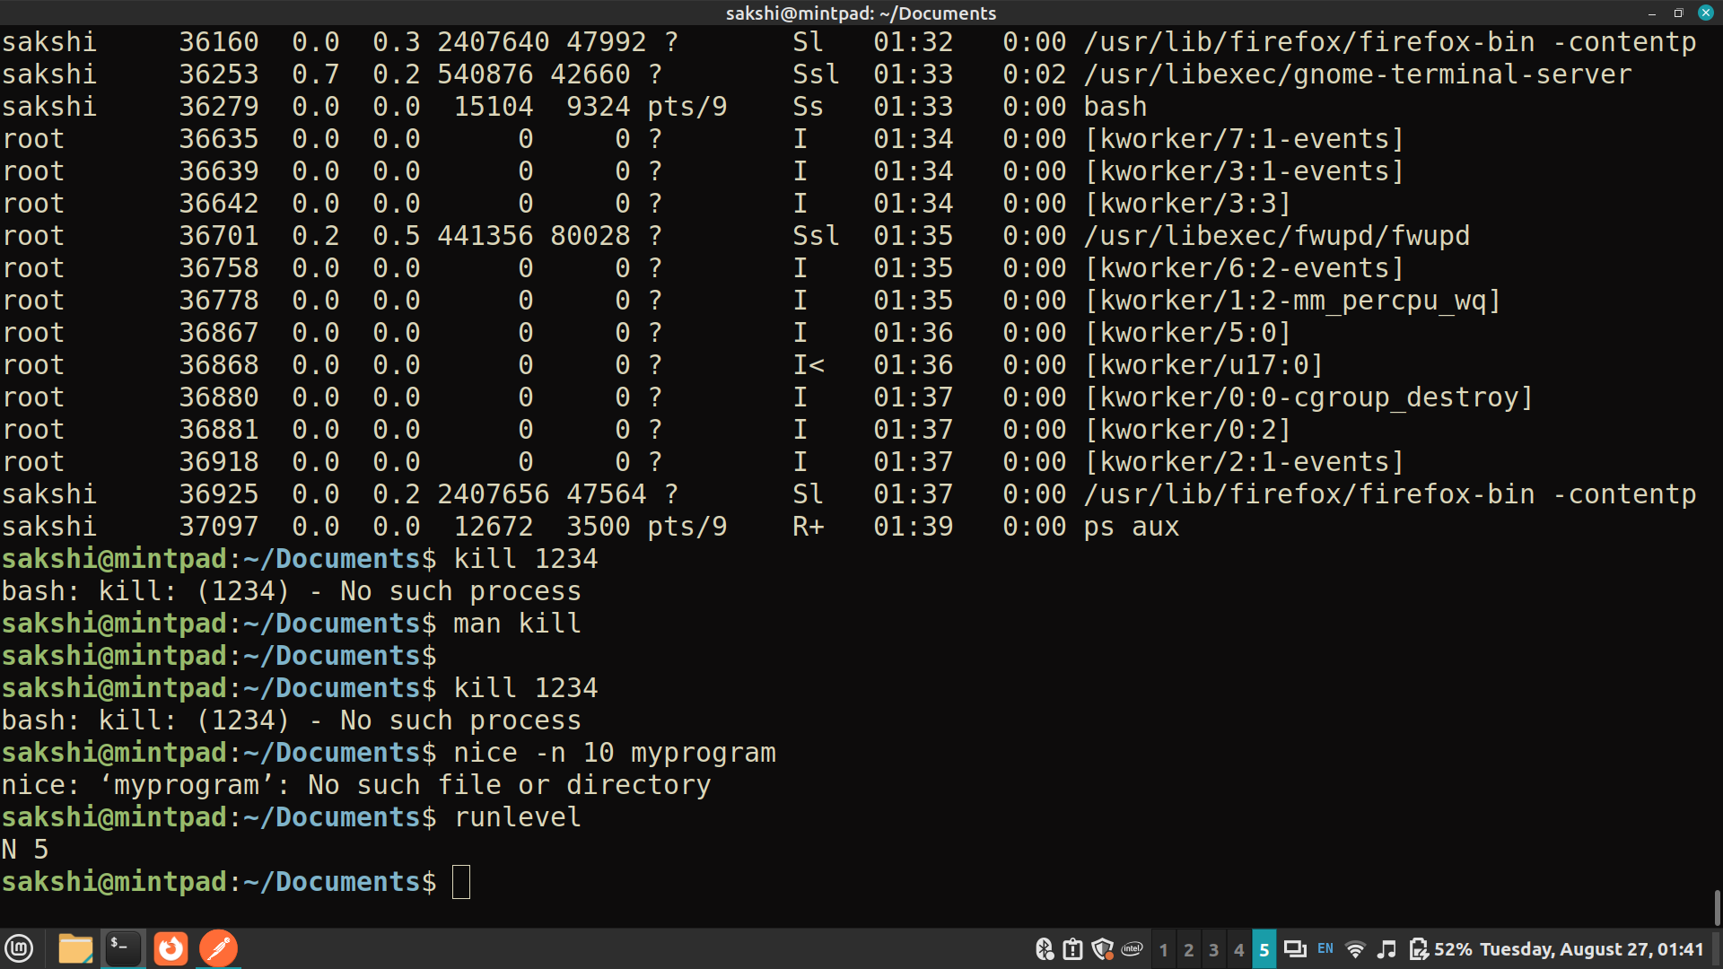
19. history - get history of executed commands
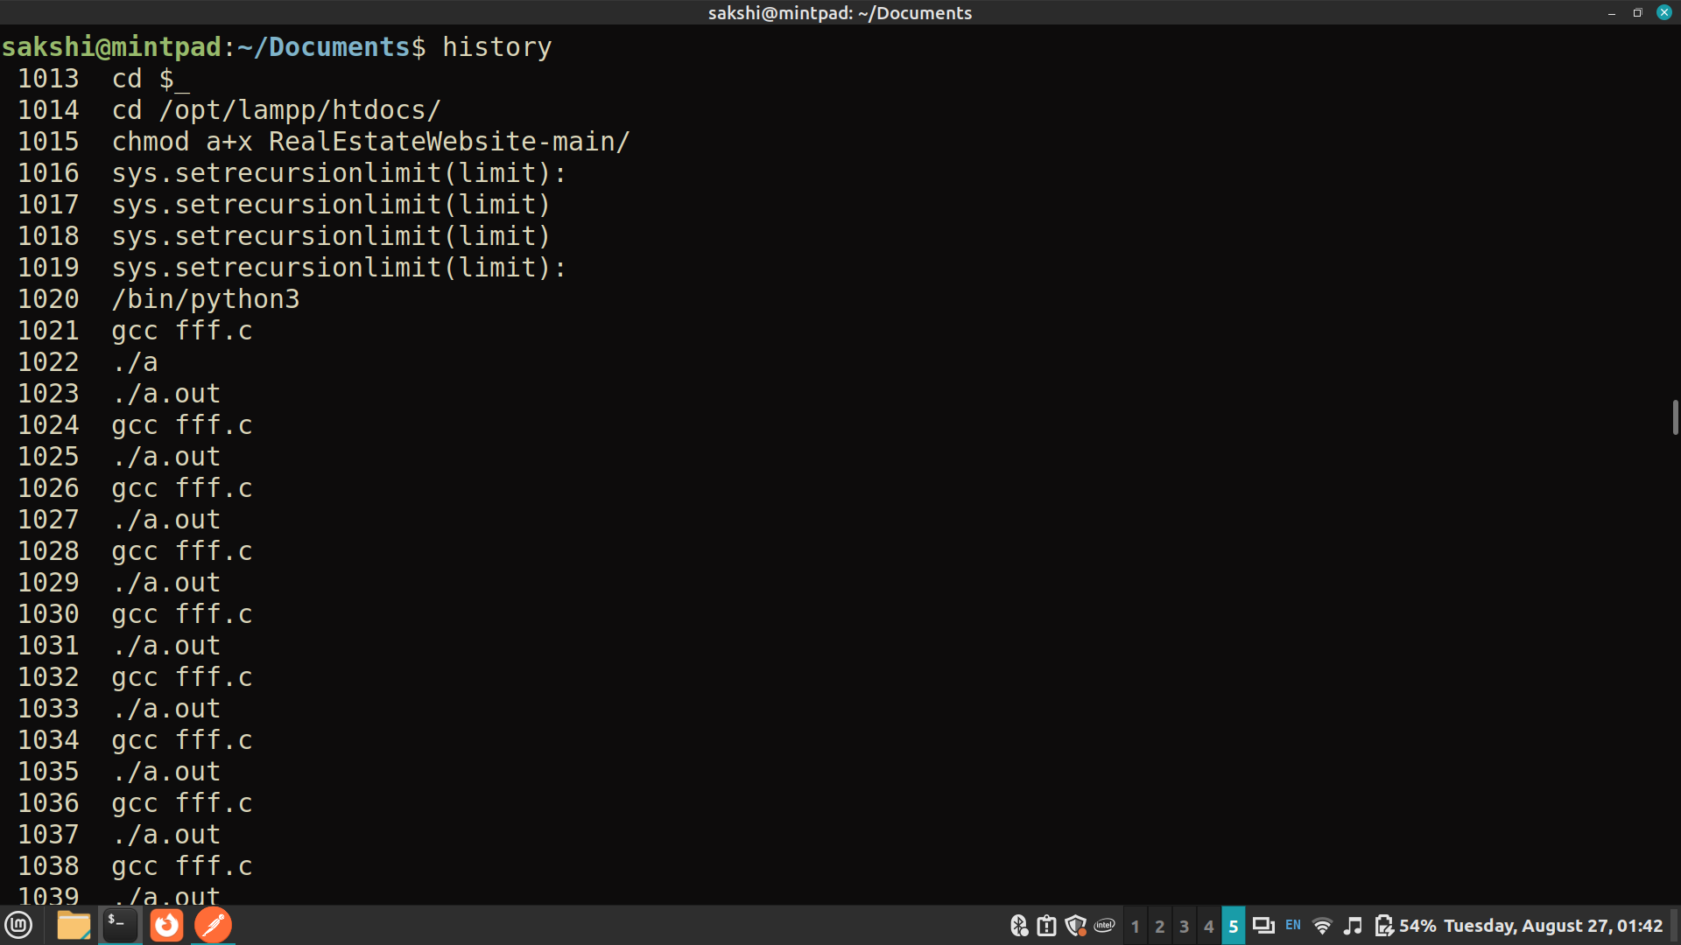
20. Run a command in background
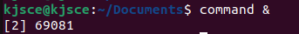
21. Suspend some commands and re-schedule them (Ctrl-z, ps, fg %sequence no of suspended process)
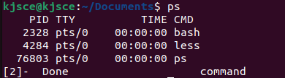

Important Unix Commands (Advanced):

1. sudo - Execute a command with superuser (root) privileges.
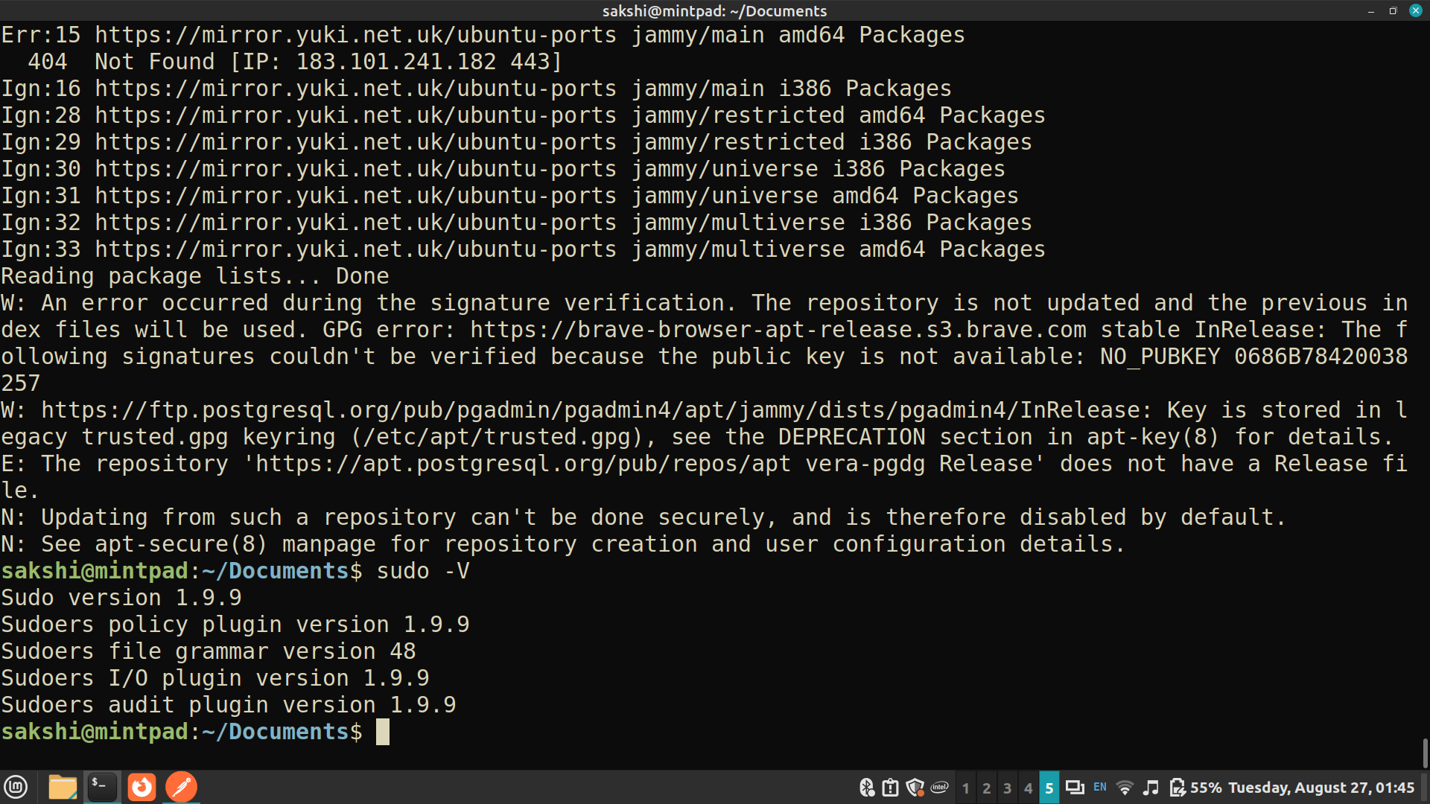

2. apt-get (Linux) / brew (macOS) - Package management commands for installing and managing software packages.
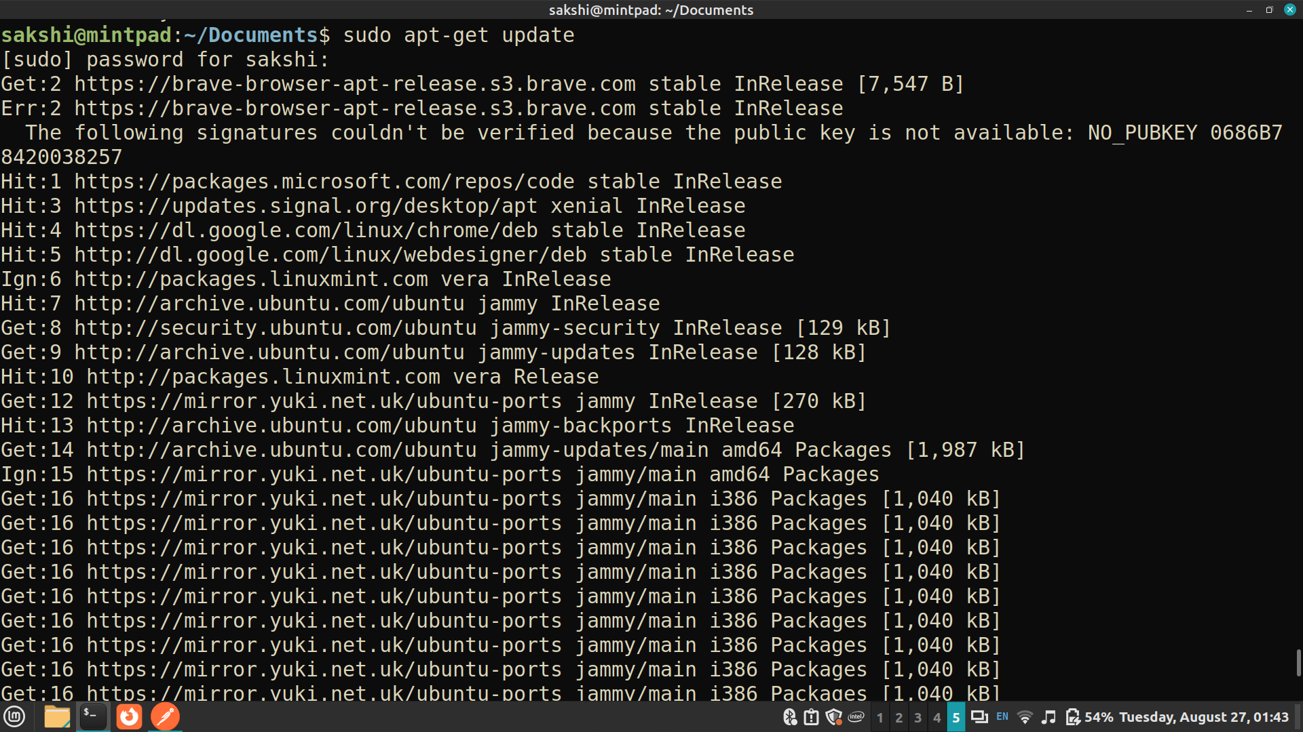
3. ssh - Secure Shell for remote login and command execution.
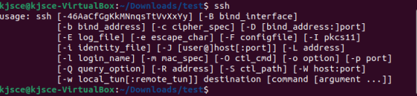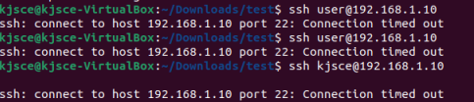
4. scp - Securely copy files between machines.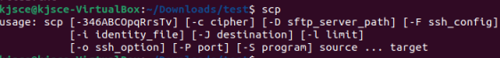
5. find - Search for files in a directory hierarchy.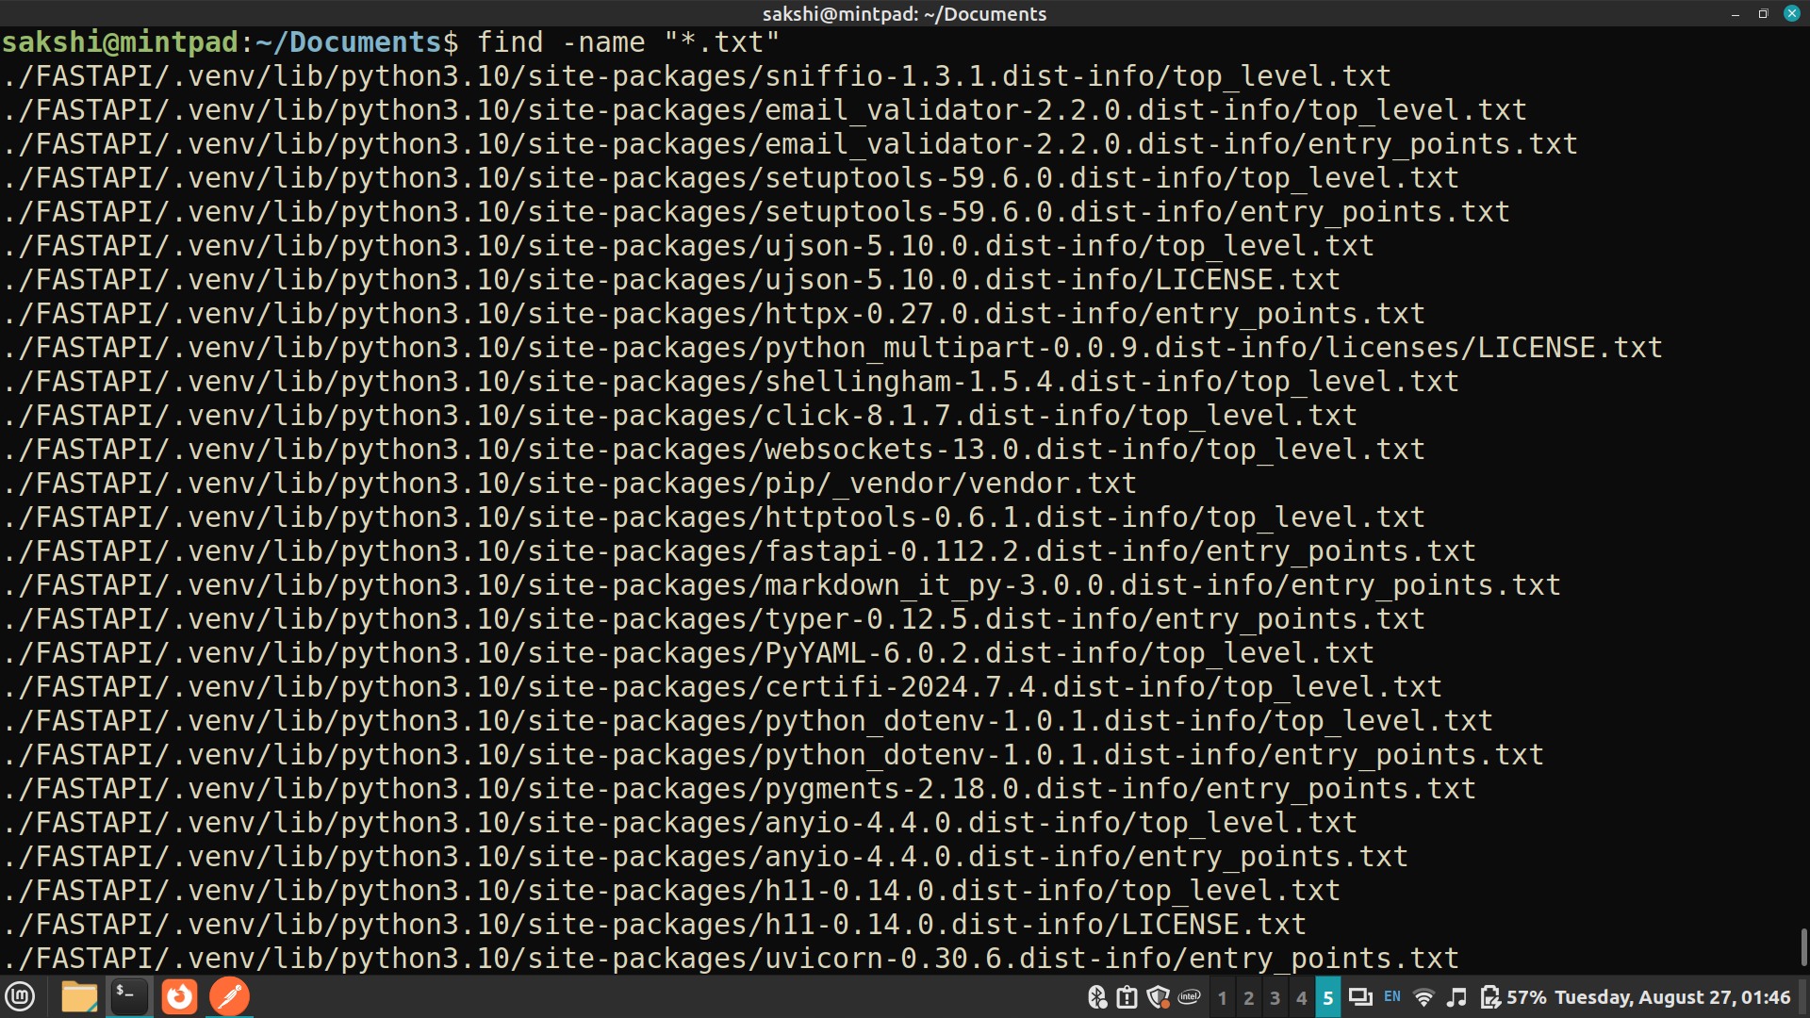

6. awk - Pattern scanning and processing language.
7. sed - Stream editor for text transformations.
8. top - Display Linux tasks and system status in real-time.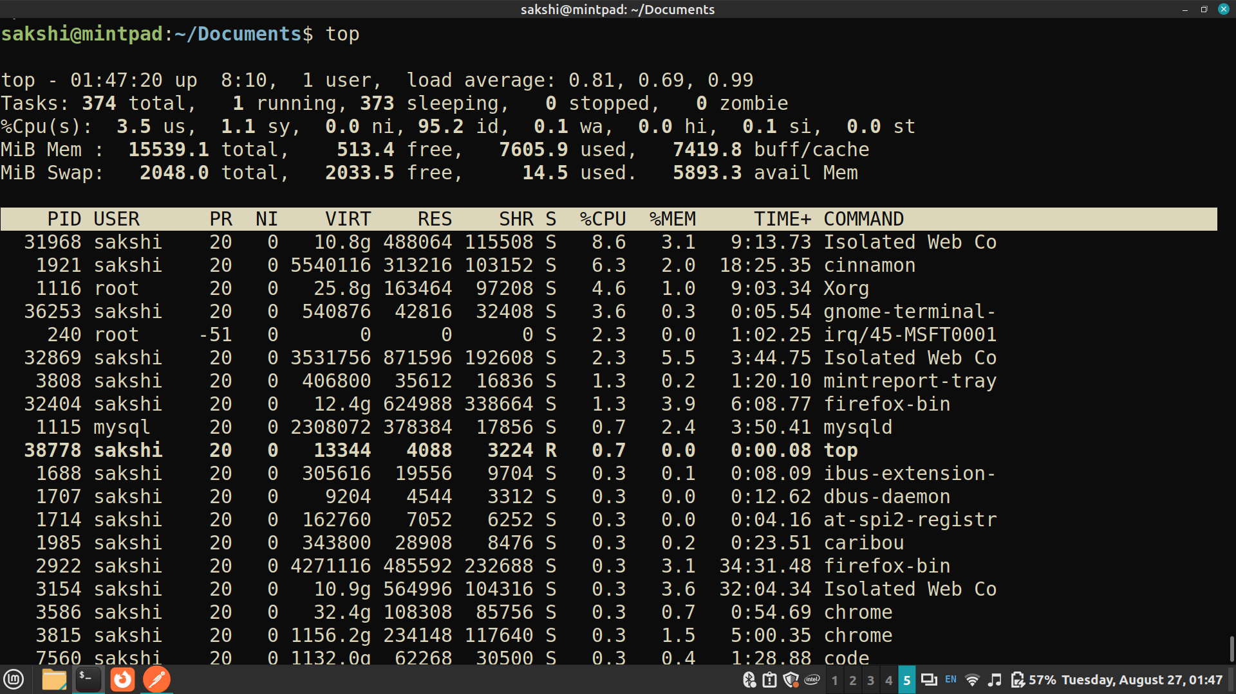
9. df - Report file system disk space usage.
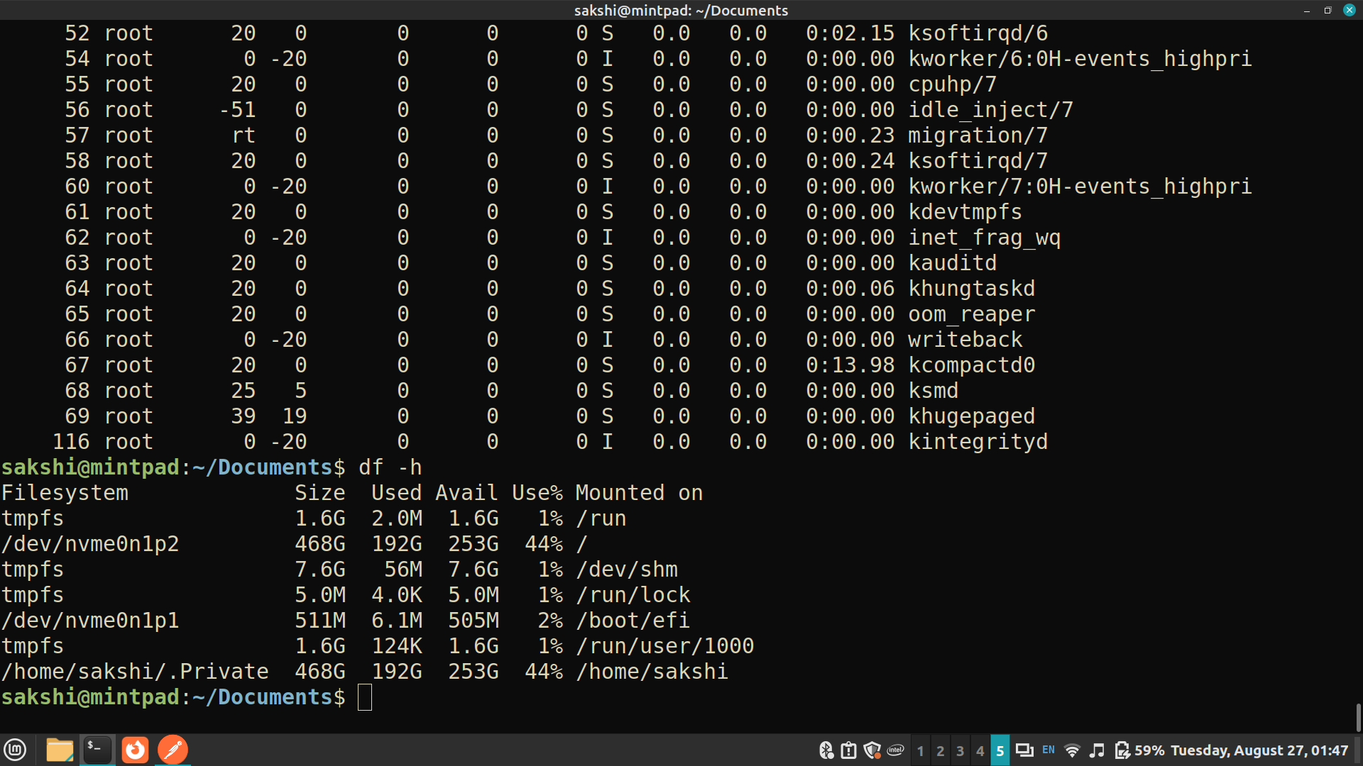
10. du - Estimate file space usage. 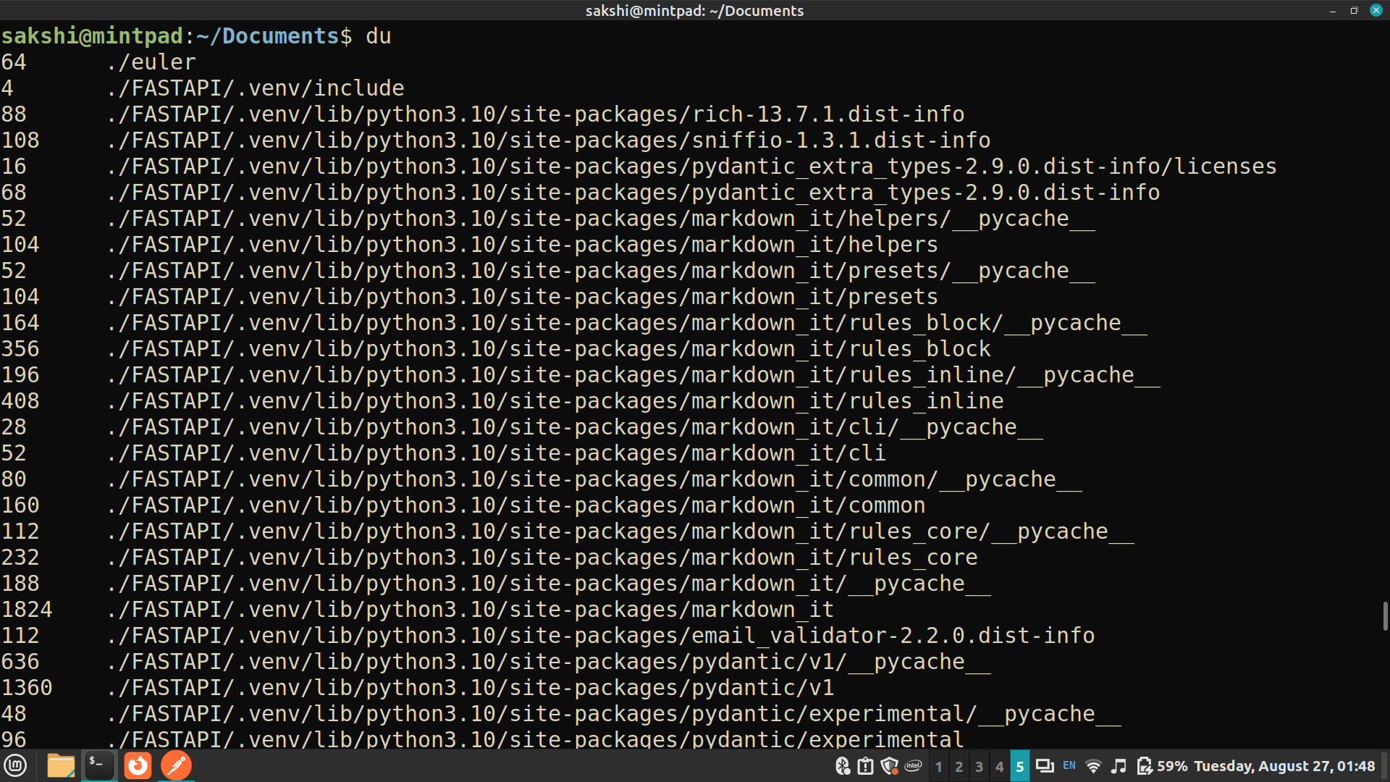
11. Edit .bash_profile file to print greeting based on time of the day. Execute the same.
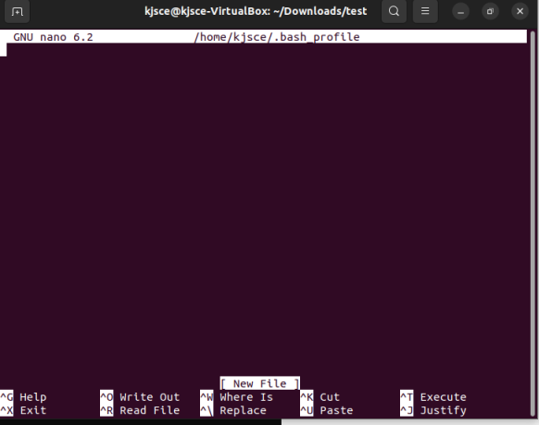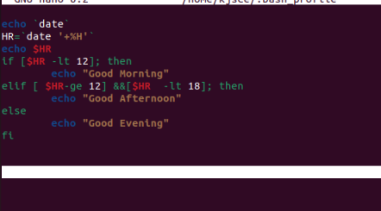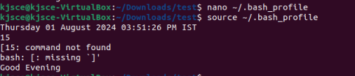
12. Run commands in multiple user profiles on same machine. (Hint: use hot keys)

Ctrl+Alt+F1 to Ctrl+Alt+F6 -Switch to different console
Ctrl+Alt+T- open new terminal

C. List of Windows OS Utilities for Exploration:

1. Task Manager :
- Purpose : Monitor system performance, view running processes, manage startup programs, and analyze resource usage (CPU, memory, disk, network).
- Usage : Identify resource-heavy processes, terminate unresponsive applications, and monitor system health.
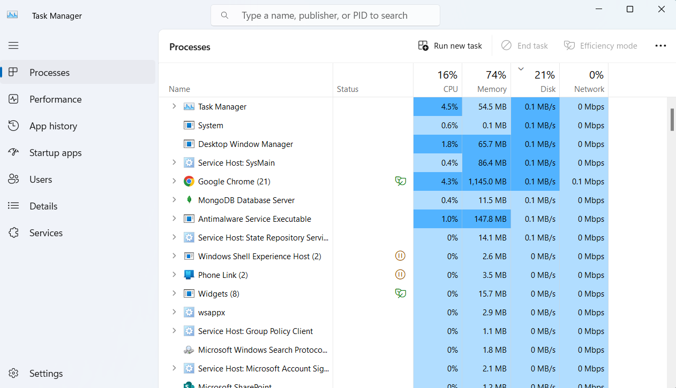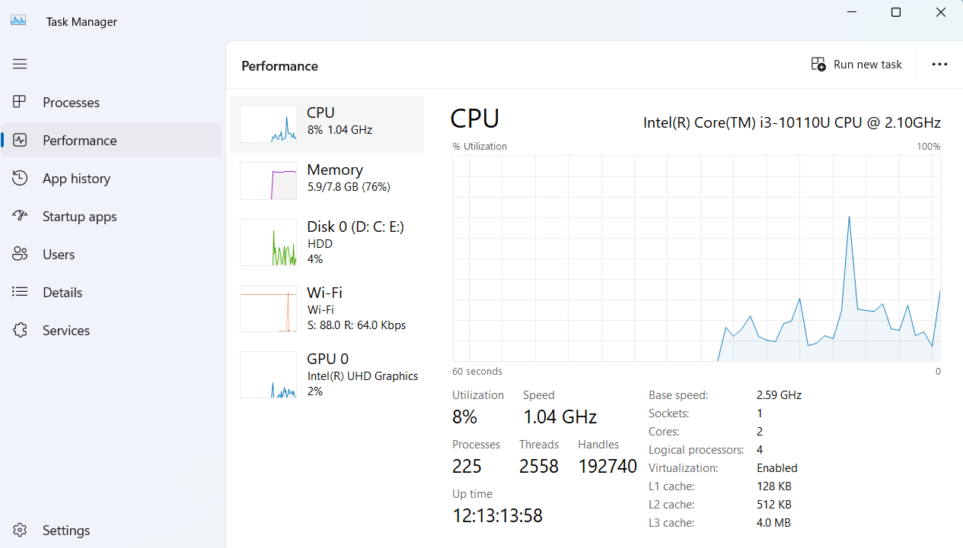
2. Resource Monitor :
- Purpose : Provides detailed real-time information about CPU, memory, disk, and network usage by processes and services.
- Usage : Monitor specific process performance, analyze disk activity, network usage, and identify resource bottlenecks.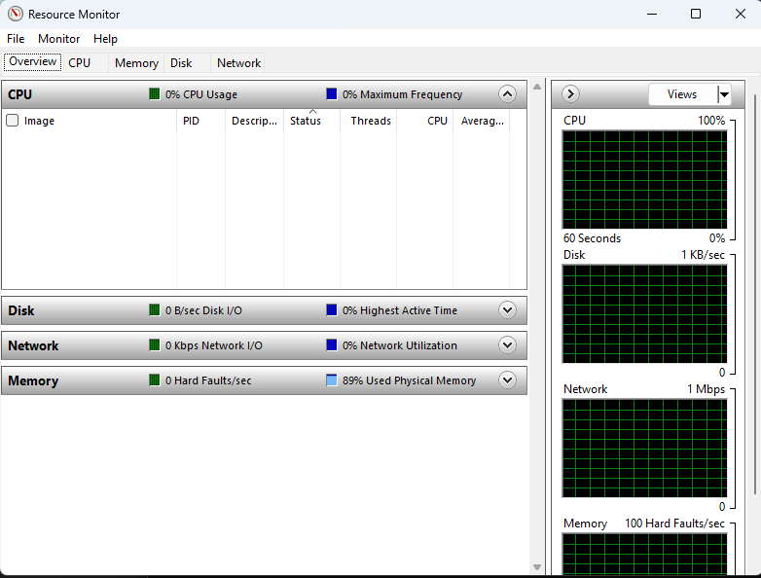

3. System Configuration (msconfig) :
- Purpose : Configure system startup, services, and startup programs.
- Usage : Enable/disable startup programs, manage boot options, and troubleshoot startup issues.
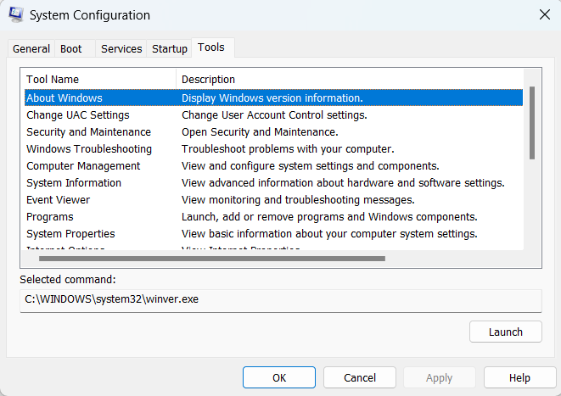

4. Disk Management :
- Purpose : Manage disk partitions, format disks, assign drive letters, and create/delete volumes.
- Usage : Partition disks, extend/shrink volumes, convert disks between different formats , fragmentation/defragmentation(e.g., MBR to GPT).
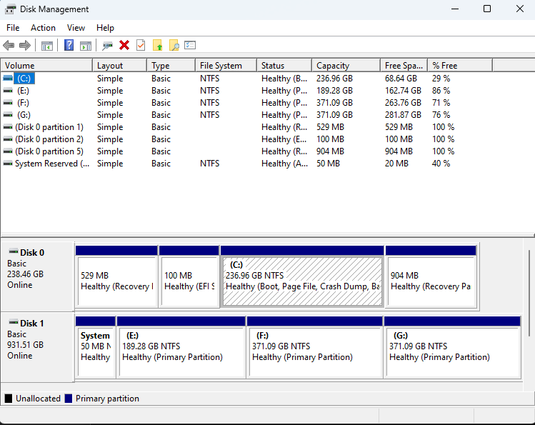
5. Event Viewer :
- Purpose : View system logs, application logs, and security logs to diagnose system and application issues.
- Usage : Investigate system errors, warnings, and information events to troubleshoot problems and monitor system health.
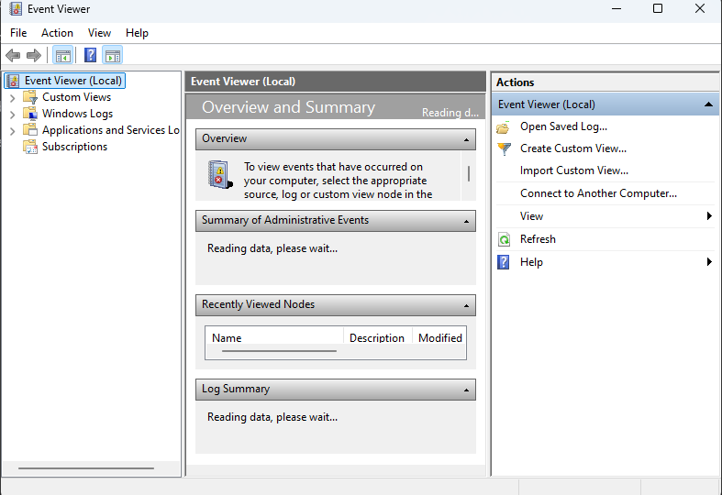
6. Performance Monitor :
- Purpose : Monitor and analyze system performance counters (CPU, memory, disk, network) over time.
- Usage : Create performance logs, set alerts based on performance thresholds, and analyze system performance trends.
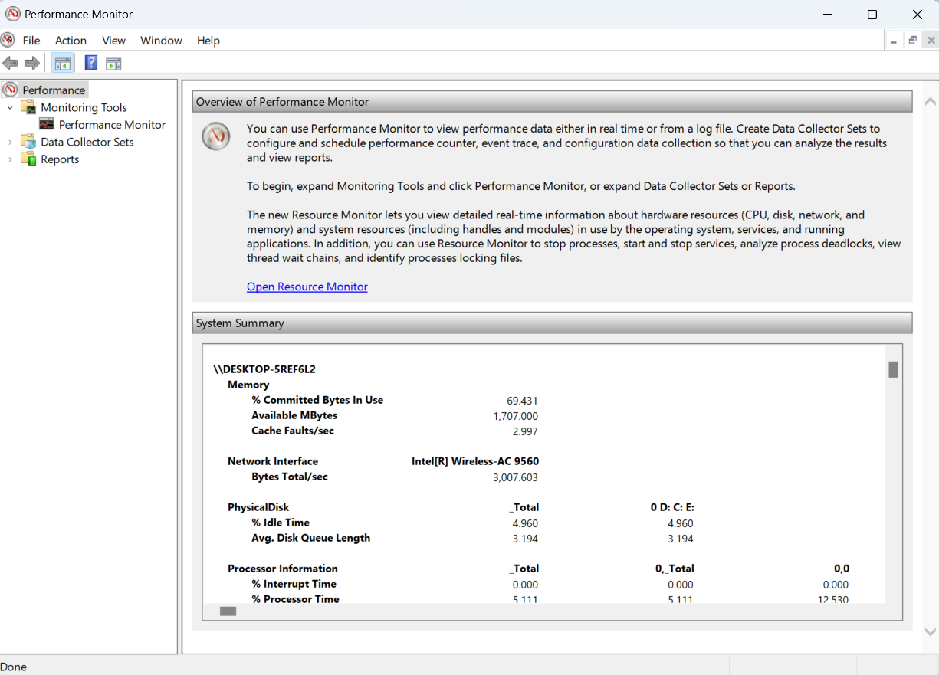

7. Task Scheduler :
- Purpose : Automate tasks and programs to run at specified times or events.
- Usage : Schedule disk cleanup, backups, maintenance tasks, and script executions.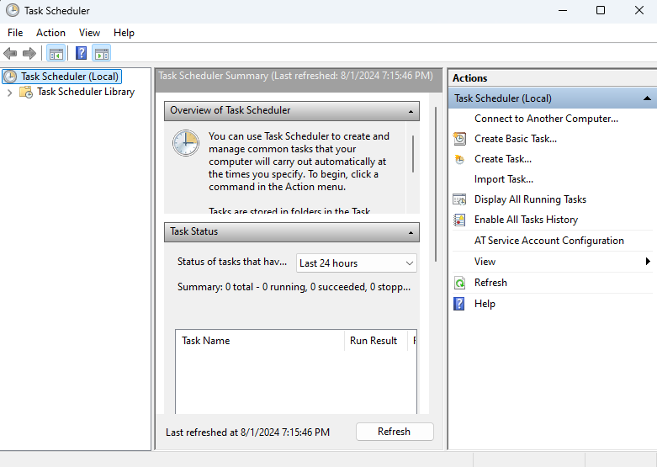

8. System Information (msinfo32) :
- Purpose : Provides detailed information about system hardware, components, software environment, and system settings.
- Usage : Retrieve system specifications, hardware details, installed software, and system configuration information.
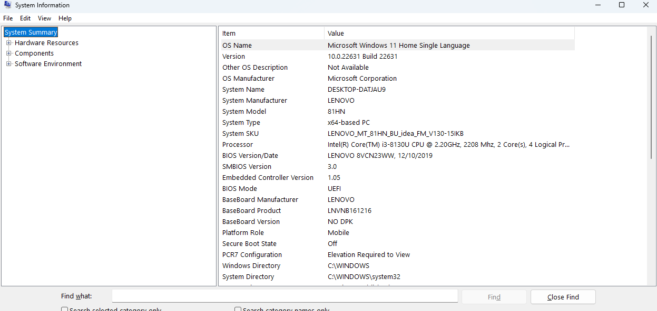
9. Registry Editor (Regedit) :
- Purpose : Edit and manage the Windows registry, which stores system configuration settings and options.
- Usage : Modify registry keys and values, troubleshoot system settings, and configure system behaviors.

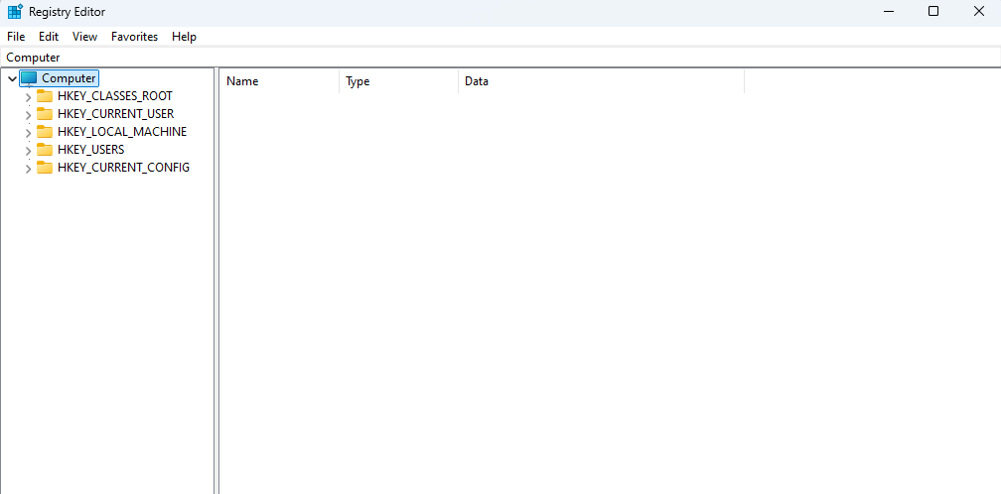
Task: check applications and programs that run on startup and enable/disable them as per personal preferences.

